Parent Council Fundraiser: Guess the Bear’s Birthday!
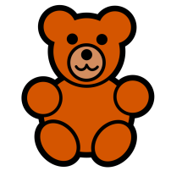
Get the chance to win a wonderful, big, cuddly teddy!
Members of the Parent Council will visit each class on a number of occasions over the next two weeks. Children will be given a chance to guess the bear’s birthday. Each guess will cost 20p, and all monies will go to the school’s Parent Council’s fund. The winner will be announced at the Summer Fair on Saturday 28 May 2016.
Please send in some money with your child so they can have a go!
Many thanks for your continued support.
Hanover Street Parent Council

Parent Council Fundraiser: Guess the Bear’s Birthday!
Get the chance to win a wonderful, big, cuddly teddy!
Members of the Parent Council will visit each class on a number of occasions over the next two weeks. Children will be given a chance to guess the bear’s birthday. Each guess will cost 20p, and all monies will go to the school’s Parent Council’s fund. The winner will be announced at the Summer Fair on Saturday 28 May 2016.
Please send in some money with your child so they can have a go!
Many thanks for your continued support.
Hanover Street Parent Council

