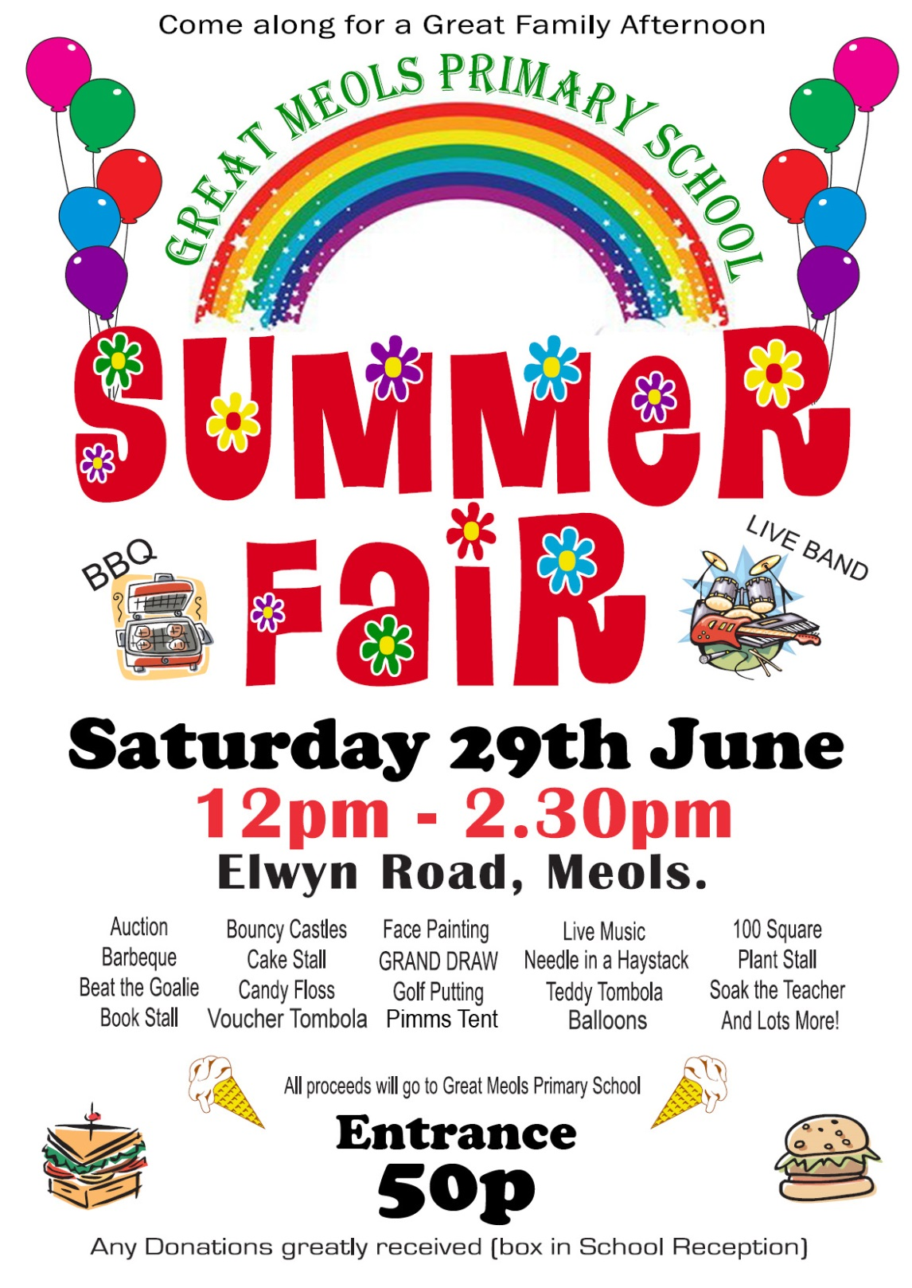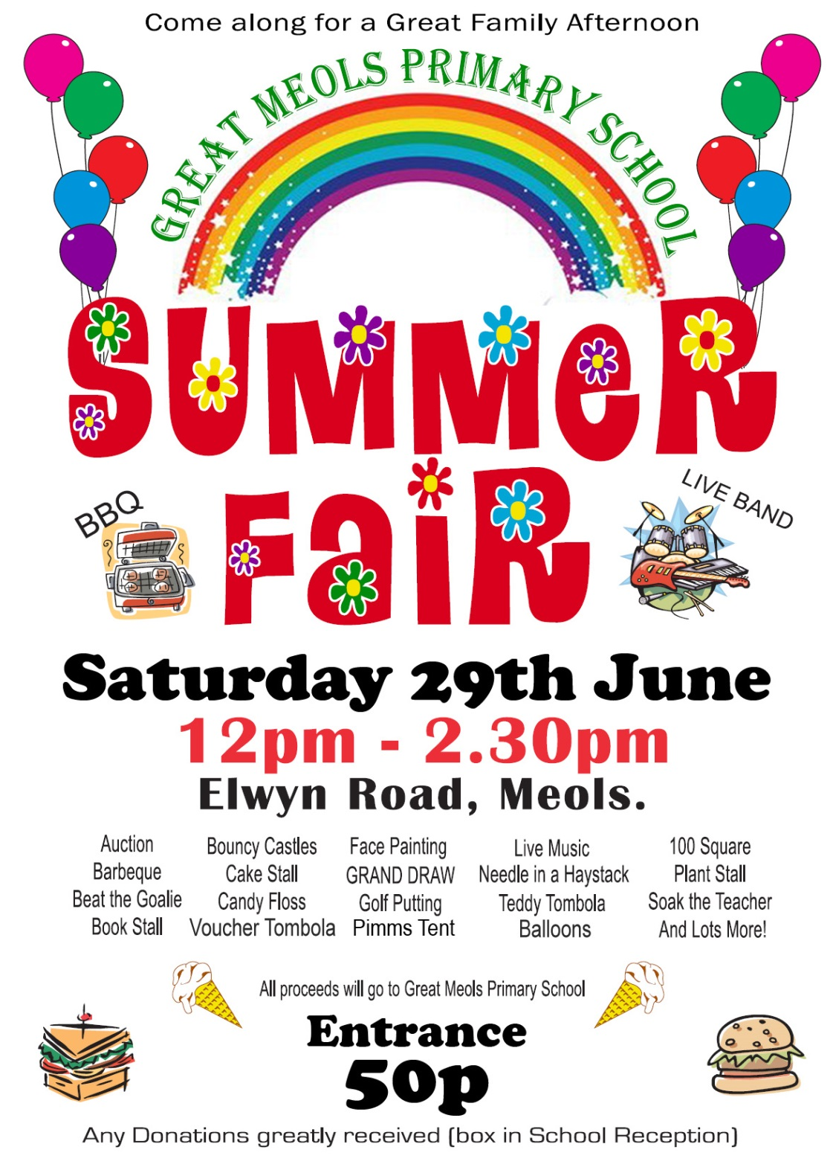

**Beat The Goalie Tin Can Alley Pot Of Luck Frisbee Challenge Crazy Golf**

**Face Painting Glitter Tattoos Nail Painting Tombola Bobs Bubbles Toy Stall Book Stall DVD Stall Brick A Brac Boat Race Popcorn Hot Dogs**

**Home Bakes Teas & Coffees Inspire Lots More!**

**Beat The Goalie Tin Can Alley Pot Of Luck Frisbee Challenge Crazy Golf**

**Face Painting Glitter Tattoos Nail Painting Tombola Bobs Bubbles Toy Stall Book Stall DVD Stall Brick A Brac Boat Race Popcorn Hot Dogs**

**Home Bakes Teas & Coffees Inspire Lots More!**

**Come along for a great family day!**









**All donations gratefully received**

All proceeds go to Hanover Street School

**Adults £1, Kids 50p**

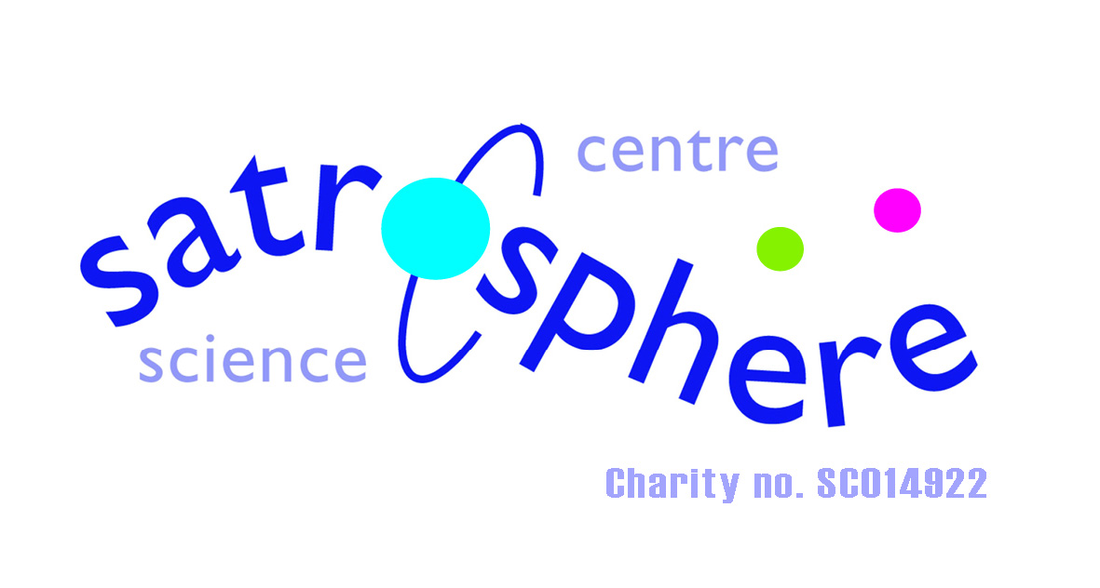

###### **Saturday 28th May, 2016**

**10am – 12 noon**

**Hanover Street School**

**HANOVER STREET**



**Adults £1, Kids 50p**



**All donations gratefully received**

All proceeds go to Hanover Street School

###### **Saturday 28th May, 2016**

**10am – 12 noon**

**Hanover Street School**

**Come along for a great family day!**







**HANOVER STREET**