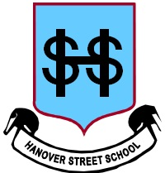
Homework Task – Another logo design!
The Parent Council would like a logo to go on letters – especially when they are asking local businesses, etc., for their support. Please use the spaces provided to draw a logo (or 2!) for the Parent Council.
If you can (and maybe with some parent help), write a couple of sentences underneath to explain your design (what it means and why you chose it to be that way). The main themes are partnership, teamwork and school improvement.
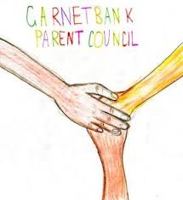
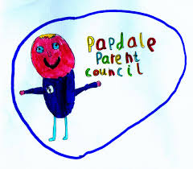
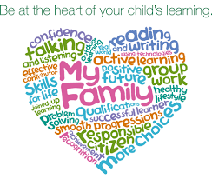
Here are a few designs from other schools in the country!
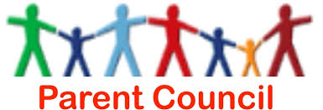

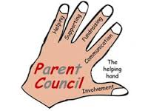
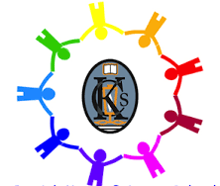

Please return by Friday 3/2/2017
What the design means and why you designed it in this way: | What the design means and why you designed it in this way:

