SCOTTISH ENTERTAINMENT & CEILIDH EXTRAVAGANZA
BURNS DAY CELEBRATIONS, 2018
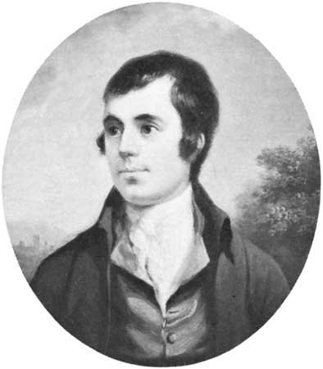
At Hanover Street School, as part of our Burns’ Day Celebrations, you may be aware that we have an annual Ceilidh celebration. All classes, including nursery, rehearse performances (poetry, songs and dances) and perform to the other classes and parents in the community.

Performance for Pupils
This will take place on the afternoon of Tuesday 23 January 2018. We ask that all children wear a touch of tartan.

Performance for Parents/Wider Family & Community Members
This will take place on Burns’ Day, Thursday 25 January 2018.
Due to the high volume of people attending, and after parental feedback last session, we are splitting this into 2 sessions this year – am & pm.

Morning Session: 9.30 – 11.00am
Afternoon Session: 1.30 – 3.00pm

Both morning and afternoon sessions will be the same performances (apart from morning and afternoon nursery). The classes, wearing a touch of tartan again, will repeat some of their performances so that parents can share in the children’s successes. Refreshments will be provided and we hope it to be a relaxed, informal and enjoyable time.

Please consider coming along to one of the sessions. A maximum of 2 places per family are available for either performance. Please complete the tear-off slip below and return by Friday 19 January to let us know if you wish to request places and the number you require. *We hope to accommodate everyone but you may not receive your preferred time.
Charitable Contributions
This year, members of the pupil council will have a collection bucket for any financial donations. These will be donated to the children’s charity “Children 1st” as part of their annual Kilts for Kids campaign. Please consider bringing along a small donation!

Yours sincerely

Mr Alan Markey, Acting Head Teacher

SCOTTISH ENTERTAINMENT & CEILIDH EXTRAVAGANZA

We will attend the ceilidh on Thursday 25 January: YES NO

We require _____ places for the Morning Session: 9.30 – 11.00am
We require _____ places for the Afternoon Session: 1.30 – 3.00pm

Signed: Date:
Name of pupil(s): Class(es):

