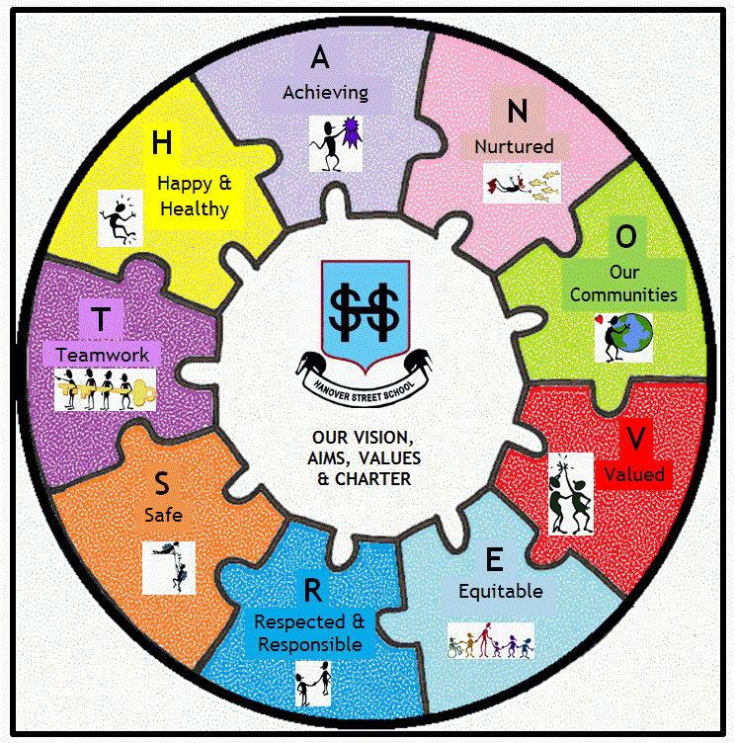
“H” is for Healthy!
(School Vision, Values & Aims)
It’s that time of year when lots of people catch viruses and colds,
with lots of coughing, sneezing and spluttering occurring.

Learning Intention:
This week, to be HEALTHY, we are revising how to wash our hands properly

Your challenge:

Remembering the demonstration at assembly, and by referring to the diagram over the page (which you can cut off and keep at home), design a small poster to explain to people how to wash their hands at the RIGHT TIME, FOR THE RIGHT LENGTH OF TIME, and in the RIGHT WAY.

You can be as creative as you like, but there are some success criteria:
- A clear title
- Some reasons for why washing hands is important (this can be in words or pictures)
- Good use of pictures
- Bright and bold and eye-catching!!
- And for P4-7, some writing of sentences or paragraphs to explain.

There will be 3 winners chosen from each class (Gold, Silver, Bronze) and these will be enlarged, laminated and displayed around the school.

-------------------------------------------------------------------

Name:
Class:
Parent Signature:

