Hanover Street School
Beach Boulevard
Aberdeen
AB24 5HN

Tel 01224 569880
Fax 01224 589116
E-mail – hanover@aberdeencity.gov.uk
Website - http://hanover.aberdeen.sch.uk/
Twitter - @HanoverStSch

12 January 2018

SCHOOL VISION, VALUES AND AIMS – Further Parent Consultation

As you know, we set a Christmas Holiday Homework Challenge to inform you about our new school vision, values & aims. It is based on the United Nations Convention for Rights of the Child (UNCRC).

Our school values and aims are described by the acronym, “HANOVER ST” and they are referred to on a weekly basis at school assemblies:

Happy & Healthy
Achieving
Nurtured
Our communities (local, national and international)
Valued
Equitable
Respected & Responsible

Safe
Teamwork
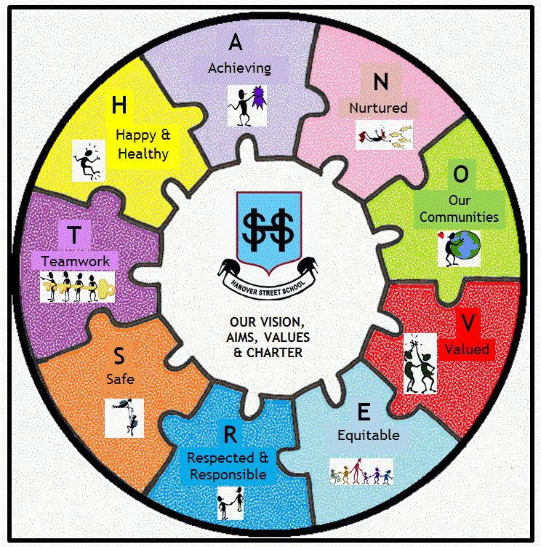

Policy Development
This term we aim to finalise our new behaviour policy and begin consultation for updating our Anti-Bullying policy. This vision is central to these policies and it is important that the whole school community is aware of it and what it means.
This term, from January to March, to make the wider school community more aware of this vision and what each part of “HANOVER ST” means, we would like to set simple weekly homework challenges. These will be introduced at assemblies on Fridays. We ask that as parents, you discuss these tasks with your child, encouraging completion of them. This is important in our working towards the Rights Respecting School Award. We are currently at Bronze level (rights committed) and are working towards our Silver level (rights aware).

This week’s challenge will be sent home on paper. However, to reduce waste (we are an Eco-School too!), subsequent challenges will be sent home on a Groupcall message/Google Classroom, with a link to a task. These will be available on the school website, and some paper copies will be available in classes, if preferred.

Many thanks for your continued support. We look forward to seeing and displaying what the children produce in their challenges!

Yours sincerely
Miss Gillian Forbes, Depute Head Teacher

