CHRISTMAS HOLIDAY HOMEWORK CHALLENGE
SCHOOL VISION, VALUES AND AIMS – Parent Consultation
At the end of last session, we revised our school values and aims.
Here they are in a lovely Christmas wreath for you!

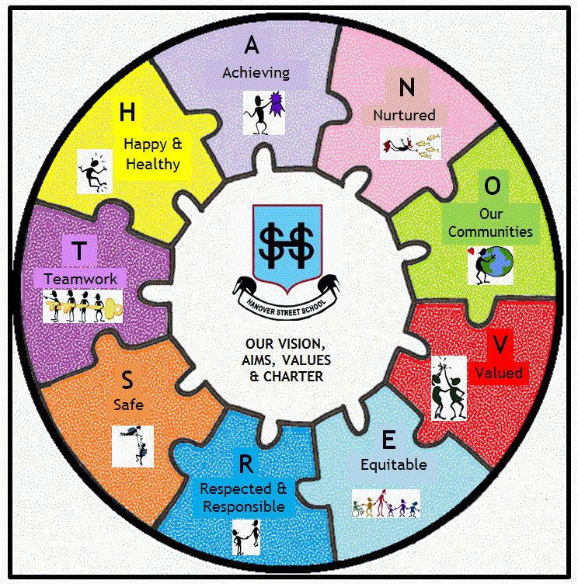

If you haven’t already noticed, your child will be able to tell you what they spell!
Our school values and aims are described by the acronym,
“HANOVER ST”:

Happy and Healthy

Achieving

Nurtured

Our communities (local, national and international)

Valued

Engaged

Respected and Responsible

Safe

Teamwork

These are referred to on a weekly basis at school assemblies.

But why and how did we decide on this?

UNCRC
These are in line with the United Nations Convention for Rights of the Child (UNCRC).

Children everywhere have the right:  • to survival  • to develop to the fullest  • to protection from harmful influences, abuse and exploitation  • to participate fully in family, cultural and social life | The four core principles of the Convention are:  • non-discrimination  • devotion to the best interests of the child  • the right to life, survival and development  • respect for the views of the child
The Convention protects children’s rights by setting standards in health care, education and legal, civil and social services (UNICEF 2011 – www.unicef.org/crc/)
GIRFEC
The Scottish Government have taken the UNCRC forward in using the GIRFEC Approach. This stands for Getting It Right for Every Child. This approach is defined around 8 Well-being indicators, which are described in the well-being wheel here:
The Well-being indicators are aligned with the range of rights specified by UNCRC to enable all children and young people to grow and develop, and to reach their full potential.
You will see all of the indicators in our acronym. (Though we did have to be a bit creative and change included to valued!)
CHRISTMAS HOLIDAY HOMEWORK CHALLENGE!
H | Happy  &  Healthy | Have lots of fun!  Enjoy all the lovely food and treats  (we can be good in the New Year because life is all about balance!)
A | Active  &  Achieving | Learn and play a new game – a board game, a jigsaw puzzle. Do this with others – a console game on your own doesn’t count!
N | Nurtured | Tell someone, “I love you”, and explain why you mean it. (If you think this is a bit weird,  just give a compliment instead!)
O | Our Communities | Watch something on the TV and find out how Christmas and New Year is celebrated here, in the local community, or further afield in our global community!
V | Valued | Value and appreciate some of the “little things”. Say “thank you!”
E | Equitable | Equitable means everyone needs different things and we should be fair to make sure they get them. Think of the things you have – are they needs, or extra lucky wants?  Have a wee think…
R | Respected  &  Responsible | Remember to use your manners over the holidays – you might want to use the French you have learned.  Look after your new toys.
S | Safe | Be safe in the snow, or if you are out using new toys e.g. bikes/scooters.
T | Teamwork | Work together to help others – make some food, help do the dishes, or assist in taking down the Christmas decorations. Teamwork works!

