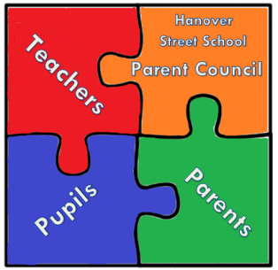

Hanover Street School
Parent Council Meeting
16th of January 2018 at 9.15am
AGENDA

- Welcome

- Apologies and matters arising

- Head Teachers updates
. Update on School improvement Plan and PC’s involvement in it.
. School vision – how to share with parents and community.
. Behaviour Policy updates.
. Anti-Bullying Policy – council policy and school’s consultation.
. Ceilidh – arrangements.
. World Book Day – target specific parents (dads and EAL families?)/people to be reading champs in class (Volunteers to read a story!)

- Treasurer update

- PTA update
. Winter Fair follow-up – thanks to local businesses.
. Sponsored events for fundraising – discuss.
. Bingo Night in Feb and related risk assessment.
. Fundraising Thermometer – target and display.

- Chair’s Community Update
. Wales St. Garden.
. Participatory Budgeting info.

- AOCB

- Date and Time of next meeting

