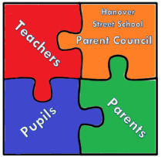

Hanover Street School
Parent Council Meeting
Tuesday 27 March 2018 at 1.45pm
AGENDA

- Welcome

- Apologies and matters arising

- Head Teacher’s updates
- School vision update
- Rights Respecting Schools Update
- Eco Update – Flying Pigs Project
- Nursery and school positive relationships and behaviour policies update
- Anti-bullying policy update
- Management of Head Lice Prevention & Infection Policy

- Treasurer update
- Financial Audit (as per Aberdeen City Council Financial Guidelines for Parent Councils/PTAs)

- PTA update
- Thermometer
- Bunny drive – info, leaflet, organisation, teas/coffees/juice & biscuits
- Easter hamper raffle
- Delivery of thank you cards
- Sponsored events
- Separate PTA meeting?

- Chair’s Community Update
- Participatory budgeting applications
- Preparation for meeting on Saturday 10 March

- AOCB
- Global Learning Partnerships Project/Miss Forbes/Rwanda/fundraising events
- P7 hoodies

- Date and Time of next meeting

