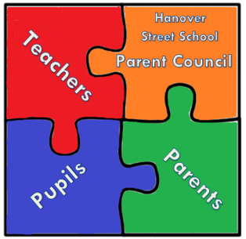

Hanover Street School
Parent Council Meeting
28th of March 2018 at 1:45 pm
AGENDA

- Welcome

- Apologies and matters arising

- Head Teacher’s updates

- Manning the book fair on Tuesday 24th of April and Wednesday 25th of April – during day and parents evenings – volunteers required.
- Parent night stand re behaviour policy/class dojo???

- Treasurer update

- PTA update

- Feedback from parent council survey
- Bunny drive event update
- Delivery of thank you cards update

- Chair’s Community Update

- PB funding – planning to use the money –what for and how
- 10th of March event updates

- AOCB

- PC Fund, where will money go/what are the targets?
- Rwanda trip – confirm any donations?
- Another Vice Chairperson?
- New disco supplier?

- Date and Time of next meeting

