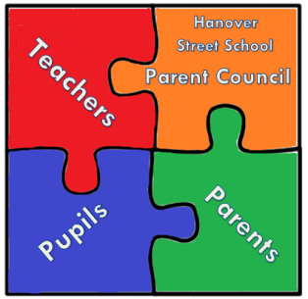

Hanover Street School
Parent Council Meeting
28th of May 2018 at 9:15 am
AGENDA

- Welcome

- Apologies and matters arising

  - GDPR
  - Online Child Sexual Exploitation – discuss parental engagement strategies

- Head Teacher’s updates

  - HT post
  - Salvation Army Donations
  - Outdoor Project
  - Connecting Cultures project
  - French (1+2 languages) showcase
  - P7 Activities Week
  - Regional Improvement Collaborative (Northern Alliance)
  - Clubs/Wider Achievement/Hanover Defenders

- Treasurer update

  - Finalising /auditing of last year’s account

- PTA update

  - Summer Fair preparations
  - Summer disco and sports day details
  - Updates about Parent Council members photos to be displayed on school notice board
  - Delivery of thank you cards update- compliment slips

- Chair’s Community Update

- AOCB

  - Lollypop ladies retirement party
  - School parking issue

- Date and Time of next meeting

