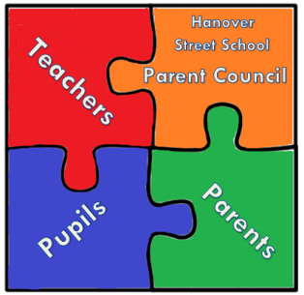

Hanover Street School
Parent Council Meeting
30th of April 2018 at 9:15 am
AGENDA

- Welcome

- Head Teacher’s updates
- Manning the book fair – volunteers required.
- Parent night stand re behaviour policy/class dojo???- Miss Forbes consultation with teachers.
- Mr Markey updates about Parent council section in the school newsletter

- Treasurer update

- PTA update

- Feedback from parent council survey- Miss Julie-Anne updates about Parent Council members photos to be displayed on school notice board
- Delivery of thank you cards update- compliment slips
- New Disco Supplier for autumn disco. Any updates

- Chair’s Community Update

- PB funding – Any idea implemented to use the money- what for and how.
- PC Fund, where will money go/what are the targets?- any updates

- AOCB

- Rwanda trip – confirm any donations?
- Lollypop Ladies Retirement
- Parking Issues
- Summer Fair

- Date and Time of next meeting

