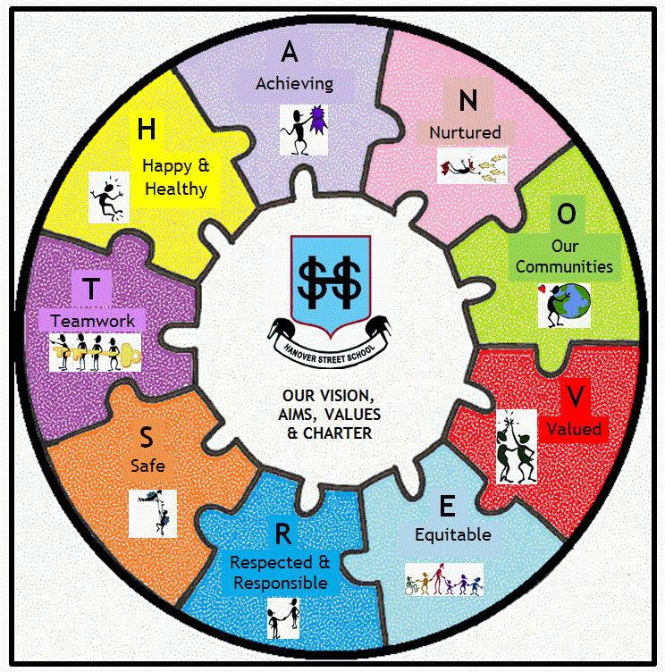
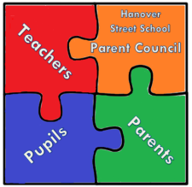

Why are we asking for your information?
Hanover Street School Parent Council collects the information about you in this form in order to process your data for parent/carer activities as part of our function. We will keep this information for a maximum of five years from the date it was initially collected. We may share this information with Hanover Street School where necessary as part of our function. The Hanover Street School Parent Council does not use an automated process for making decisions about you or the services you may receive from us.

Your Data, Your Rights
You’ve got legal rights about the way the Hanover Street School Parent Council handles and uses your data, which include the right to ask for a copy of it, inaccurate data to be update/amended, and to ask us to stop doing something with your data. You may withdraw your consent by contacting the Parent Council Chairperson and/or Secretary.

More information about all of the rights you have is available on the Information Commissioner’s Office (ICO), (ico.org.uk/for-the-public/).

You also have the right to make a complaint to the Information Commissioner’s Office, (www.ico.org.uk). They are the body responsible for making sure organisations like the Parent Council handle your data lawfully.

Legal Basis for Processing

Hanover Street School Parent Council understands our legal basis for processing your data to provide you with these services relating to your role as Article 6(1)(a) of the General Data Protection Regulation, because you have consented by providing information. You can withdraw this at any time, as explained above.

