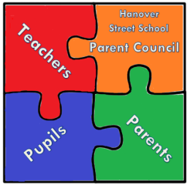

Fancy Dress Disco
Tuesday 2 October 2018
@Hanover Street School Gym Hall

Primary 1-3: 6.00pm – 7.00pm
Primary 4-7: 7.15pm – 8.15pm

Come dressed in your fancy dress costume!
(Spooky outfits, princesses, pirates, favourite character etc.)

Entry £2, to be paid on the night.
(Includes juice and biscuits)

All children must be dropped off and picked up by an adult on time.
Each child must be signed in and out and a contact number must be left.

PARENTS WELCOME TO STAY
For parents that would like to stay, tea, coffee and biscuits will be on sale
at 50p a cup in the dining room.
Stay and have a cuppa and a chat
or come through and have a dance with us all in the gym hall!

SEE YOU THERE!

