NA02125_NA02125_NA02125_NA02125_

Hanover Street Nursery Newsletter

September, 2018

**Beach Boulevard, Aberdeen, AB24 5HN**

**Telephone: - 01224 569880 Nursery Mobile: - 07741 236509**

**E-mail : - hanover@aberdeencity.gov.uk Website: - hanover.aberdeen.sch.uk Twitter : - @HanoverStSch**

## Welcome back!

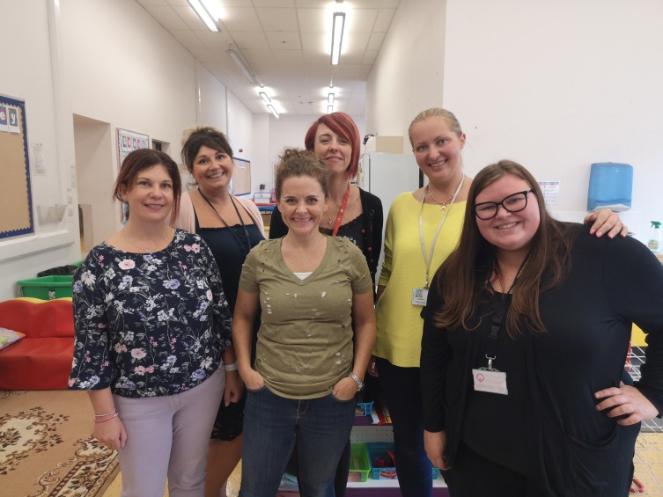Welcome back to all children, mum, dads, aunties, uncles, grandmas, grandads, childminders and of course, our wonderful nursery team! We hope you all had a restful but fun summer and enjoyed the wonderful sunshine. It’s so good to see you all back with a lovely smile on your faces.

We welcome Mrs Davina Smith to nursery this year as our Nursery Class Teacher. Mrs Smith joined Hanover Street School towards the end of last session and is doing a great job settling into the Hanover Street School & Nursery Team. She will happily introduce herself to you all and we welcome her with open arms into our nursery. ☺

We are delighted to welcome back Mrs Leaper after her maternity leave. She is returning part-time, working Wednesday to Friday.

**New entry doors into nursery – AM/PM Doors**

## Families continuing in nursery will have noticed that we have changed our entry into the playroom. Instead of Red and Blue entrances, we have an AM (morning) and PM (afternoon) entrance.

## AM children and families will enter nursery in the door furthest from the stairs, PM in the nearest door. Now that the cloakroom areas may be a bit busier, we ask that all bags and shoes get taken home each day with your children. This will also help improve health and safety/cleaning. Thank you.

## Development Priorities this Session

## As with every year, we have some development priorities for this school session. These are fully detailed in the Standards and Quality Improvement Plan (SQUIP), which will soon be available on our school website. Until then, I will detail them briefly below under the 4 national priorities:

## 1a: Improving Attainment in Literacy – using a developmental approach to teaching literacy

## 1b: Improving Attainment in Numeracy – using guidance and assessment to support teaching in numeracy.

## 2: Closing The Attainment Gap between The Most and Least Disadvantaged Children in School – Embracing a “Visible Learning” approach (staff using research to support children knowing where they are in their learning, allowing them to take increasing responsibility for their own learning, etc.).

## 3: Improvement in Children’s Health & Wellbeing – continue to embed a nurturing approach in nursery by increasing team awareness of the nurturing principles and using this to support children’s emotions, behaviour and learning.

## 4: Improvement in Employability Skills

## (Developing the Young Workforce)

## – developing nursery curriculum to embrace location,

## links to businesses, and focus on skill development,

## particularly in digital technologies.

## 

## COMMENT/UPDATE SLIP—Please use this space to update us with any new contact details/email address so that we can keep you posted with emails/information. Please add any comments you wish to pass on.

## —————————————————————————————————————————

## Funding!

## As you may know, the school managed to secure £2000 through Local Governments’ Participatory Budgeting last session. This was for developing our outdoor environment and learning within it. Look out for new things happening outside – we will be spending all our money very soon!

## Also, we have been very fortunate to receive a £1500 grant for Scotland’s Government Early Learning and Childcare (ELC) Inclusion Fund. We aim to use this for training and resources to support children with Additional Support Needs, particularly with Autistic Spectrum Conditions (ASC).

## We also received £500 worth of equipment from “Local School Nature Grants”, which includes den-building kits and will be receiving training soon in how best to use this.

## Useful Reminders...

## Please make sure your child has a jacket with them every day – we go outside come rain or shine!

## Please look out for “Stay and Play” sign-up sheets this month

## Have a look on our school website and Twitter to see the fun learning we get up to here at Hanover Street!

## Please do contribute to any surveys/feedback that is requested – we do act on it where at all appropriate/relevant

## Always sign your child in and out – use your own names as parents please – we want to get to know you as individuals to help build a strong relationship. We believe that being a mummy/daddy is a part of you, but not the whole of you. ☺

## Supporting Learning at Home – Harvest Festival

## C:\Users\GForbes\AppData\Local\Microsoft\Windows\Temporary Internet Files\Content.Outlook\HXC4MOO3\IMG_20180903_110216.jpgHarvest Moon will be on Friday 21st September (our holiday weekend). As a nursery we’d like to gather a wee collection of dried/tinned foods for gifting to the Salvation Army @ Citadel. These will be shared with local families in need. If you can, please contribute to the display in nursery by FRIDAY 14 SEPTEMBER. The boys and girls will be doing fun activities to learn about Harvest – I hope their scarecrows aren’t too scary! ☺

## Birthday Celebrations

## When it is your child’s birthday in nursery, we are no longer having birthday cake as snack that day to celebrate. Even though it was delicious, as a health promoting school, and with 80 children in the nursery, eating cake was happening a bit too regularly! We are still treating your wee ones though, don’t worry. Your children will get to choose a party hat, games to play and also something special from our new treasure chest…

**UPCOMING EVENTS/IMPORTANT DATES FOR DIARY**

|  |  |
| --- | --- |
| **September 2018** | **October 2018** |
| Sun 9th: Education Sunday @ Citadel, 10.15am – all welcome  Mon 3rd – Fri 14th: Maths Fortnight in nursery!  Wed 12th: Early Talkboost Meeting for parents – invitations will be given  Wed 12th: Whole School Staff Training on Outdoor Learning, after school  Thurs 13th: Dahlicious Day (Roald Dahl story celebration, info to follow)  Thurs 20th: Minibeast Hunt with Countryside Rangers, here at school  Fri 21st – Mon 24th: Holiday Weekend | Mon 1st: Mrs Smith at First Aid Training update  Tues 2nd: Welcome to Miss Ross, work experience pupil  Mon 8th: Mrs Lemmon at First Aid Training update  Fri 12th: Last day of term 1  Mon 15th to Fri 26th: October Holidays  Mon 29th: Start of term 2 |