Acceptable Use Policy
Rules for Acceptable Computer and Internet Use

While using the ICT resources, computers or the Internet in Aberdeen City Schools:
- I will only use the computer for educational activities and will not attempt to access chat rooms or Instant Messaging Services.

- I will not use bad language in any message I send or attempt to bully or harass anyone.

- I will not try to visit sites which might have material which others might find offensive – pornography, racist, violent or similar sites.

- I will inform staff if I find any inappropriate material on a computer I am using.

- I will not reveal the personal address, phone number or password of others, myself nor use another’s password.

- I will not use any computer in such a way that would disrupt the computer use of others, nor interfere with any computer security measures the school may have in place.

- I will not attempt to access files belonging to others.

- I will respect copyright and not use anything I download without the approval of a member of staff.

- I will only upload, download or copy files with the permission of a member of staff.

- I am aware that monitoring and random checks are made on all computers and email messages sent and received.
All rules relating to computer use apply to all ICT resources, computer networks and stand-alone computers in the school.
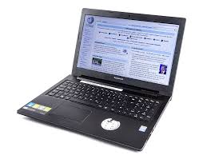
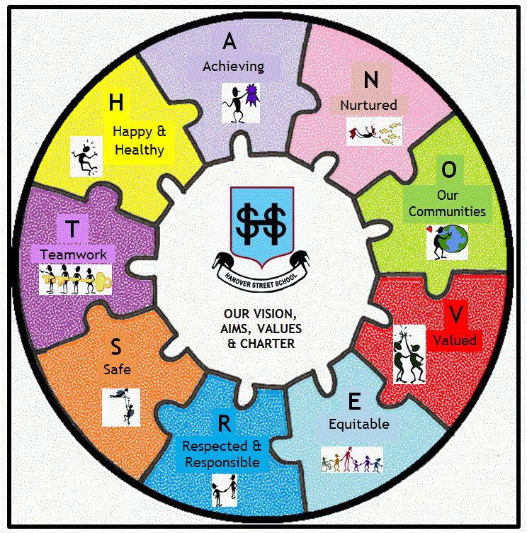
These rules also apply to all information sent electronically within the school, including text messaged or pictures sent by mobile phones.
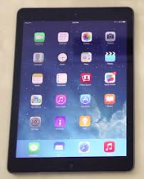
Acceptable Use Policy
Rules for Acceptable Computer and Internet Use
PARENT/CARER
As the parent/carer of (Child’s name):
I have read the rules for Acceptable Computer and Internet Use and understand that these rules apply when my child is using school ICT resources and the Internet.
I have gone through the rules with my child and explained the rules with my child and explained their importance and the consequences of breaking the rules.
I understand that the school will make every reasonable effort to restrict access to all controversial material on the Internet, but will not hold them responsible for materials my son or daughter acquires or sees as a result of the use of the Internet at school.
I give my permission to Hanover Street School to allow the child named above to use the computers and Internet in school. (This can be changed at any time by contacting the Head Teacher.)
Parent/Carer Signature: Date:

Hanover Street School may produce web pages, ICT presentations, video presentations, educational or interest articles for magazines or other media. These materials are often used to show good practice and to celebrate a school’s achievements.
No child’s work or photograph will be used without his/her permission but we also need permission from parents/carers to be able to publish the child’s work or record activities by camera or video camera. Please be assured that the child’s safety will always be of paramount importance and no personal information will be made public.
Please sign this copyright release if you are happy for your child’s work to be shared in this way. (This can be changed at any time by contacting the Head Teacher).
Parent/Carer Signature: Date:

PUPIL (if old enough)
I have read the rules (or spoken with my parent/carer about them) for Acceptable Computer and Internet Use and know the importance of these rules.
I know that if I break these rules, I may lose the right to use the schools’ computer facilities or face further disciplinary action.
Pupil’s Signature: Date:

*after signing this agreement, this will be stored in your child’s file in the school office
*for ease of future reference they are available to view on our school website

