Come along and enjoy a Valentine’s activity with your child!
Make a card, enjoy a craft, have a cup of tea and have a lovely time!
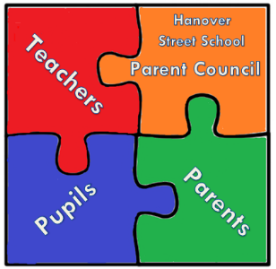
Where? School’s Dining Room
When? After school on Thursday 14th February 2019, 3.15pm – 4.30pm
Cost? Free, though any small donations are welcome!
Please complete TODAY and return the reply slip TOMORROW so that we can prepare enough resources and refreshments.
Thank you! From the Parent Council

Valentine’s Activity Afternoon
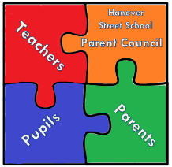
Name of Child: Class:
Name of Parent:
Total number of children attending:
Total number of adults attending:
I am willing to help at an activity/stall: YES NO
Contact Number:

(these details will be kept in line with GDPR:
that is, kept confidential, kept for no longer than required and destroyed safely afterwards)

