**Hanover Street**

**School**



**Admission and Induction Pack**

**for New Families**

***Session 2019/20***

**CONTENTS**

* Welcome letter from the Senior Leadership Team, Mr Markey (HT) & Miss Forbes (DHT)
* School Vision, Values & Aims
* Organisation of School Day and Year

**H – Happy & Healthy**

* Health Promoting School
* Playtime and Lunchtime, Snacks/“Playpieces”
* School Meals, Packed Lunches, Taster Sessions for Parents, Supervision
* Sickness & Head Lice, etc.
* School Health Service
* Medication & Tooth Brushing – Childsmile!
* Runny Noses
* Physical Education (P.E.) or “Gym”
* Clubs & Activities

**A – Achieving**

* Our Curriculum
* Curriculum Levels

**N – Nurturing**

* The principles of nurture

**O – Our Communities**

* Global Citizenship & English as an Additional Language (EAL) Service

**V – Valued**

* Communication
* School Office
* Home/School Communication Methods
* Pupil and Parent Participation

**E – Engaged & Equitable**

* Additional Support Needs (A.S.N.)
* English as an Additional Language (E.A.L.)

**R – Respected & Responsible**

* Positive Relationships & Behaviour Policy
* Expectations of Staff, Parents and Pupils
* School Uniform, School Clothing Grants
* Pupil Belongings - Valuables/Jewellery, Name Labels

**S – Safe**

* Child Protection
* Health and Safety
* Lining Up
* Anti-Bullying Policy
* Anti-Weapon Policy
* Accidents/First Aid
* Physical Education (P.E.)/Gym Kit
* Code of Practice for Jewellery in Physical Education

**T – Teamwork**

* Welcoming and Including Parents
* Parent Council, Parent Helpers
* Current Staff & Class List

|  |  |  |
| --- | --- | --- |
|  | Hanover Street School  Beach Boulevard  Aberdeen  AB24 5HN  Direct Dial: 01224 569880  hanover@aberdeencity.gov.uk | ACC Crest New  Integrated Children & Family Services  Operations  Marischal College  Broad Street  Aberdeen, AB10 1AB  Switchboard 03000 200 292  [www.aberdeencity.gov.uk](http://Www.aberdeencity.gov.uk) |
|  | |

Dear Parents/Carers

Welcome to our school, and therefore the Hanover Street team! As parents, you have been and will always remain the first and main on-going educators of your children. Therefore parental partnership now, and in the years ahead is the key to success for your child.

*‘Parents, carers and families are by far the most important influences in a child’s life. Parents who take on a supportive role in their child’s learning make a difference in improving achievement and behaviour.’*

**(Guidance on the Scottish Schools**

**(Parental Involvement) Act 2006)**

We know that, for the most, moving schools/year groups is an exciting time. We also acknowledge that for some, it can be emotional and overwhelming, and a few parents and children may have some anxieties about this change. Throughout your welcome here, we hope to give to the necessary information to make you and your child’s start at Hanover Street School as smooth and as easy as possible.

We hope that this booklet will be a useful tool for you to refer to, leading up to and after your child has enrolled and started with us. If you feel you require any further information at any point, please contact the school office where they will direct your query to the relevant people.

Finally, thank you very much for your continued support in your child starting school.

Yours sincerely

The Senior Leadership Team (SLT)



Mr Alan Markey Miss Gillian Forbes

Head Teacher Depute Head Teacher

**\*Please note this is a summarised version of our main School Handbook.**

**This Handbook is available from the school office, or electronically, on our school website.**

**SCHOOL VISION, VALUES & AIMS**

**Vision Statement**

Hanover Street School’s vision is to create a welcoming, friendly, happy and safe environment to enable our children to achieve to their full potential and become successful learners, confident individuals and responsible, effective contributors to society.

**School Aims**

Our School Aims are:

* to provide a welcoming, caring and friendly environment where children feel happy, safe and secure.
* to provide challenging and appropriate learning experiences to promote successful learners within a full and balanced curriculum;
* to promote responsibility, fairness, honesty and respect for others to enable children to become responsible citizens;
* to develop communication, co-operation, perseverance and resilience to create effective contributors to society;
* to encourage and develop good relationships between children, parents, staff and the wider school community.

**School Charter and Acronym**

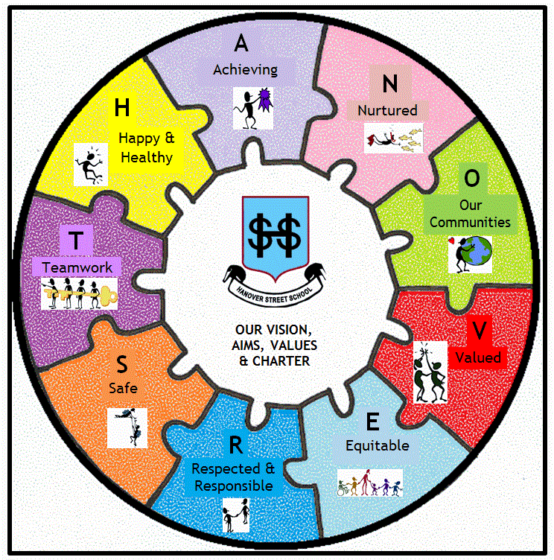To make the above vision and aims more meaningful and memorable to the whole school community, we display and simplify these aims in the charter below, which uses the acronym **“HANOVER ST.”**

**H – Happy & Healthy**

**A – Achieving**

**N – Nurturing**

**O – Our Communities (Being part of & involved with them)**

**V – Valued**

**E – Engaged & Equitable**

**R – Respected**

**S – Safe**

**T – Teamwork**

**\*To detail this vision, most of this booklet is organised under these headings**

**ORGANISATION OF THE SCHOOL DAY/YEAR**

**Nursery**

Morning class: 8.30am – 11.40am

Afternoon class: 12.20pm – 3.30pm

There is a staggered pick up and drop off time of 20 minutes for each nursery class.

Morning class drop off is between 8.30am – 8.50am and pick up is between 11.20am – 11.40am.

Afternoon class drop off is between 12.20pm – 2.40pm and pick up is between 3.10pm – 3.30pm. It is important that children do not arrive before or after these times.

**Primary**

|  |  |  |
| --- | --- | --- |
| **Primary 1** | **Primary 2 & 3** | **Primaries 4 - 7** |
| 9.00 – 10.30am  Morning Break 10.30 – 10.45am  Lunch – 12.15pm  Afternoon – 1.30 – 3.15pm | 9.00 – 10.30am  Morning Break 10.30 – 10.45am  Lunch – 12.30pm  Afternoon – 1.30 - 3.15pm | 9.00 – 10.30am  Morning Break 10.30 – 10.45am  Lunch – 12.00noon  Afternoon – 1.00 –3.15pm |

**ARRIVAL/PICK-UP AT SCHOOL & PLAYGROUND INFORMATION**

Children should not arrive at school more than 15 minutes before the start of the school day.

For pupils to reach their full potential, it is important that they arrive in time to come into school with their class ready to start the school day. It is also very important that children are collected on time. Young children can become confused and upset if they are left at school once all their classmates have left.

If you are going to be late for any reason, please contact the school office as soon as possible. If your child is to be collected by anyone other than their parent/carer you must let the school know too.

If you are unable to collect your child, please ensure your child knows who he/she is going home with.

For health & safety reasons, dogs are not permitted in the school grounds.

**SCHOOL TERM & HOLIDAY DATES**

**FOR SESSION 2019-20 (updated due to VE Day holiday)**

**Further information for sessions after 2019-20 can be found on**

**Aberdeen City Council Website:** [**http://www.aberdeencity.gov.uk/**](http://www.aberdeencity.gov.uk/)

**In Service Days (these are included into each term below)**

Monday 19 August 2019 &Tuesday 20 August 2019

Thursday 21 November 2019 & Friday 22 November 2019

Tuesday 18 February 2020 & Wednesday 19 February 2020

Thursday 7 May 2020

**Term 1 (8 weeks)**

**20 August 2019 to 11 October 2019**

**In-service days-** Monday 19 August 2019 & Tuesday 20 August 2019

**Term starts –** Wednesday 21 August 2019

**September holiday -** Friday 20 September to Monday 23 September 2019

**Term ends** - Friday 11 October 2019

**October holiday** - Monday 14 October to Friday 25 October 2019

**Term 2 (8 weeks)**

**28 October 2019 to 20 December 2019**

**Term starts** - Monday 28 October 2019

**In-service days** – Thursday 21 November 2019 & Friday 22 November 2019

**Term ends** - Friday 20 December 2019

**Christmas holiday** - Monday 23 December 2019 to Friday 3 January 2020

**Term 3 (13 weeks)**

**6 January 2020 to 3 April 2020**

**Term starts** - Monday 6 January 2020

**Mid-term holiday** - Monday 17 February 2020

**In-service day** - Tuesday 18 February 2020

**In-service day** - Wednesday 19 February 2020

**Term ends** - Friday 3 April 2020

**Spring holiday** - Monday 6 April to Monday 20 April 2020

**Term 4 (11 weeks)**

**21 April 2020 to 3 July 2020**

**Term starts** - Tuesday 21 April 2020

**In-service day** - Thursday 7 May 2020

**May Day/75th Anniversary VE Day holiday** - Friday 8 May 2020

**Term ends -** Friday 3 July 2020

**H – HAPPY & HEALTHY**

**Health Promoting School**



As a health promoting school we reinforce a positive message encouraging healthy habits to children through the activities, experiences, snacks and drinks provided. In doing so, we hope to support you, the parent, in developing good lifestyles choices and eating habits for your child.

**Playtime and Lunchtime**

Unless the weather is excessively icy, wet or windy, children will be expected to play outside during playtime and lunchtimes, Children should be sent to school with appropriate outerwear to suit the weather and/or time of year.

**Snacks/“Playpieces”**



Children can bring a snack to school for their “play piece”.

A piece of fruit is what we encourage. As we are a health promoting school, crisps, sweets, biscuits, etc. are discouraged. Also, it is only a short time between break and lunchtime; if the children are eating only fruit they are more likely to enjoy a hearty lunch.

Water bottles can also be brought in by the children, but we do ask that it is only water that is kept in them.

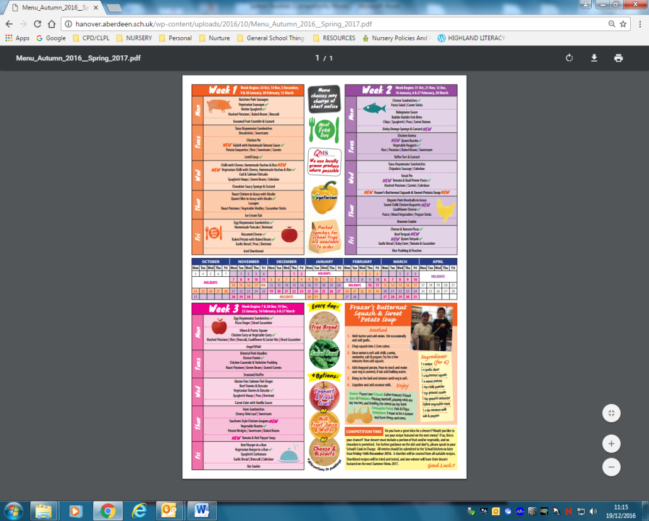

**Aberdeen City Council use a 3 or 4 weekly cycle menu. More information can be viewed on** [**http://www.aberdeencity.gov.uk/schoolmeals/**](http://www.aberdeencity.gov.uk/schoolmeals/)

**School Meals**

In Scotland, school meals are provided free for every child in Primary 1-3 and are offered once the children begin all day attendance. School meals are cooked within our own kitchens. The children are offered a choice of 3 main courses and a dessert each day. A non-meat dish suitable for vegetarians is always one of the main courses on offer. Menus are sent home with the children and are always available to download from the school website.

**\*Please let us know if your child has any allergies or religious reasons for avoiding certain foods – for these reasons, a special diet can be requested.**

**Packed Lunches**

j0232044

If you prefer, you can provide a packed lunch for your child. Please make sure that they can open packages and boxes with as little help as possible. Where children bring a packed lunch to school, parents are responsible for ensuring that lunch box contents are stored at the correct temperature, by including an ice pack where necessary. We ask that waste food and packaging are taken home with the children each day.

**Sickness**

Please do not be persuaded by an unwell child that – “they want to come to school.” Bringing a sick child to school puts all the other children and staff at risk. Children should not attend school for **48 hours after the last bout of any vomiting or diarrhoea**.

**Head Lice**

We encourage the regular checking of heads for live head lice and eggs (nits). We offer termly reminders via newsletters/text messages. If you receive a reminder this does not mean there is an “outbreak” in school. Please, if you discover live head lice, do inform the school so that we can monitor the spread of any infection, and whilst maintaining confidentiality, can make other parents aware. Our “Management of Head Lice Prevention & Infection Policy” is available on our school website.

**School Health Service**

The school works closely with the School Health team, employed by NHS Grampian. The team includes the school nurse and the school doctor. They work in close liaison with teachers and other health professionals to support the children and families. The core programme for health is detailed in the Aberdeen City Council’s Guide to Education and Children’s Services, 2018-19, (page 42), available on our school website and <https://www.aberdeencity.gov.uk/media/60>.

j0215439**Medication**

If your child needs medication at school, whether this is regular or infrequent, we are not able to administer it until the relevant permission forms and instructions are completed. These can be collected at the school office.

**Tooth Brushing – Childsmile!**

Childsmile aims to improve the oral health of children in Scotland and reduce health inequalities.

At Hanover Street, our tooth brushing programme begins in the nursery and continues through to the end of Primary 2. All the children are given their own toothbrush and teachers dispense the toothpaste and supervise the brushing. Brushing takes place whenever it is suitable for the class but it is recommended half an hour before or after food.

A letter is given to parent/carers informing them of the school/nursery participating in the tooth brushing programme. *If you do not want your child to take part in this, please write to the school within 2 weeks of receiving the letter.

A consent pack will be sent from Childsmile regarding consenting for the fluoride varnish which happens twice a year.

j0232730**Runny Noses**

As I’m sure you can imagine, we have many runny noses throughout the school year. We would thoroughly appreciate it if you could provide a box of tissues on occasion to encourage the best possible hygiene in class.

**Physical Education (P.E.) or “Gym”**

The Scottish Government recognises the positive impact physical education can have on a pupil's health, educational attainment and life chances and that it can form a key element of a school’s plan to deliver the broad health and wellbeing outcomes and experiences contained within Curriculum for Excellence.

j0078629Hanover Street is committed to ensure, as much as possible, that every school pupil will benefit from at least 2 hours of physical education, per week, in primary school. We have an experienced P.E. Specialist, Mrs Armstrong, who works in tandem with the class teacher to deliver these 2 hours over the period of a week.

For health and safety reasons, we ask that children have a suitable gym kit.

This is furthered detailed in the SAFE section of this booklet.

**Clubs & Activities**

We work closely with SportScotland and the Active Schools Network who help to develop and support the delivery of quality sporting opportunities for our pupils.

Throughout the session, your pupil may have opportunities to take part in sports/physical activities either during lunchtime and/or after school. In recent years, these clubs have included athletics, basketball and multi-activity club.

sportscotland - the national agency for sport

**A – ACHIEVING**

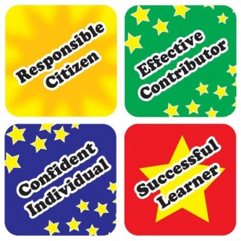**Our Curriculum**

At the heart of the Scottish Curriculum for Excellence are the 4 capacities

* Successful Learners
* Confident Individuals
* Responsible Citizens
* Effective Contributors

The curriculum works towards achieving these through the 8 subject areas listed:

|  |  |
| --- | --- |
| **Language**   * Listening * Talking * Reading * Writing   **Mathematics**   * Number, Money & Measurement * Shape, Position & Movement * Information Handling   **Health and Wellbeing**   * P.E., physical activity and sport * substance misuse * food and health * relationships   **Expressive Arts**   * Drama * Music * Art * Dance | **Religious and Moral Education**   * Christianity * World religions * Development of beliefs and values   **Sciences**   * Planet earth * Forces, electricity and waves * Biological systems * Materials   **Social Studies**   * People, past events and societies * People, place and environment * People, society, economy and business   **Technologies**   * Technological developments in society * ICT to enhance learning * Computing science * Food and textiles * Craft, design, engineering and graphics |

**Curriculum Levels**

Progression is indicated through curriculum levels, as detailed below. Most children in P1 will be working within the Early level. Curricular workshops will be available later in the session.

|  |  |
| --- | --- |
| **Level** | **Stage** |
| **Early** | The final two years of early learning and childcare before a child goes to school and P1, or later for some. |
| **First** | To the end of P4, but earlier or later for some. |
| **Second** | To the end of P7, but earlier or later for some. |
| **Third** | S1 to S3, but earlier for some. |

**Parents’ evenings normally take place around October and April. Formal written pupil reports are usually distributed prior to the April Parents’ evenings.**

## N – NURTURING

As a school, we are increasing our awareness of the ‘nurturing approach’ and embedding it further into our policies and practices.

There are 6 principles of nurture:

**The Six Principles of Nurture**

* Children's learning is understood developmentally
* The classroom offers a safe base
* The importance of nurture for the development of wellbeing
* Language is a vital means of communication
* All behaviour is communication
* **The importance of transition in children's lives**

**Ref: Lucas,S., Insley,K. and Buckland,G. (2006)**

**Nurture Group Principles and Curriculum Guidelines Helping Children to Achieve,**

**The Nurture Group Network**



**What does this mean for you and your child?**



At Hanover Street School, when your child needs care, comfort and guidance, we give it to them. We talk, we listen, and we positively reinforce routines, expectations and boundaries, looking for solutions to any problems. In comfort, we may give hugs (or in our Aberdeen dialect, a “bosie!”), put arms round shoulders, give pats on backs, sit the children on our knee, etc., as the needs of the child dictate. Please, if you would like us not to hug your child in the event of them being upset, do let us know!

**Wrap Around Care/Breakfast/After School Club**

We do not have a breakfast or after school club at Hanover Street School. There are various child-minders in the area, who offer this care facility. We also have some children from our school who attend the after-school club “Rising Light” <http://www.risinglight.org.uk/>

**O –OUR COMMUNITIES**

**(BEING PART OF & INVOLVED WITH THEM)**

At Hanover Street, we believe we are part of and contribute to our communities on all levels:

* Local
* National; and
* International & Global

On our current school roll, over 55% of our pupils come from other cultures, speaking English as an additional language. We are therefore very well placed to promote the concepts of Learning for Sustainability and developing Global Citizens, a key part of Scotland’s Curriculum for Excellence.

# What is global citizenship?

# It is a way of living that recognises our world is an increasingly complex web of connections and interdependencies. One in which our choices and actions may have repercussions for people and communities locally, nationally or internationally.

# Global citizenship nurtures personal respect and respect for others, wherever they live. It encourages individuals to think deeply and critically about what is equitable and just, and what will minimise harm to our planet. Exploring global citizenship themes help learners grow more confident in standing up for their beliefs, and more skilled in evaluating the ethics and impact of their decisions.

# What is a global citizen?

# A Global Citizen is someone who:

# is aware of the wider world and has a sense of their own role as a world citizen

# respects and values diversity

# has an understanding of how the world works

# is outraged by social injustice

# participates in the community at a range of levels, from the local to the global

# is willing to act to make the world a more equitable and sustainable place

# takes responsibility for their actions.

To be effective Global Citizens, young people need to be flexible, creative and proactive. They need to be able to solve problems, make decisions, think critically, communicate ideas effectively and work well within teams and groups. These skills and attributes are increasingly recognised as being essential to succeed in other areas of 21st century life too, including many workplaces. These skills and qualities cannot be developed without the use of active learning methods through which pupils learn by doing and by collaborating with others. These are key aspects to the Curriculum for Excellence.

**This information is taken from:** [**http://www.ideas-forum.org.uk/about-us/global-citizenship**](http://www.ideas-forum.org.uk/about-us/global-citizenship)

**The International Development Education Association of Scotland (IDEAS)** is a network of organisations and individuals involved in Development Education and Education for Global Citizenship across Scotland.

**English as an Additional Language (EAL) Service**

The EAL Service supports learning and teaching of pupils with a home language other than English (bilingual pupils) so that they reach their full potential. The Head Teacher will contact the EAL Service for an initial assessment visit to decide on the level of support the child will need. The service responds to referrals from schools in a flexible way through:

• consultation, initial assessment, advice on materials and staff support;

• teaching beginners’ groups at the EAL service premises or in their own schools;

• teaching pupils who have basic competence in English (Stage 2) and improved competence in English in the mainstream classroom from P1 to S6;

• teaching SQA English for Speakers of Other Languages (ESOL) certificated classes.

**V – VALUED**

**(communication and participation)**

**School Office**

Mostly, your first port of call to the school will be through the school office. The school office is manned from 8.30am –12.30pm & 1.30 – 3.15pm.

The school has an answering machine for leaving messages. Any visits to the school should be made through the main entrance and all visitors should report to the School Office. In line with Aberdeen City Council’s Health & Safety Policy, all visitors to school will be asked to sign in and wear a visitor’s pass badge.

**Home/School Communication Methods**

We consider our daily contact with you to be vitally important – time for us both to exchange information – for the benefit of your child. Please don’t rush away! It is helpful to share with staff any special events, or problems, happening out-with school – weddings, illnesses/deaths, family splits etc. If we are informed, we can help your child should they become unsettled. Please use the Reading Homework Diary that your child will receive to note down any queries/concerns if you cannot see the teacher at the end of the day.

At Hanover Street School we use various forms of communication:

* Telephone and face-to-face informal conversations (school number 01224 569880)
* Face-to-face parent meetings
* Annual written reports
* Newsletters
* 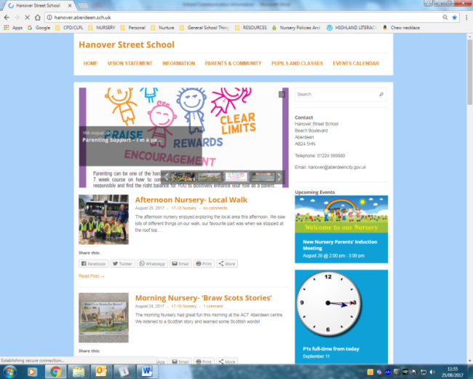School Information Line (See overleaf)
* GROUPCALL – a text messaging service for the school

We also have our school website: [**www.hanover.aberdeen.sch.uk**](http://www.hanover.aberdeen.sch.uk)

Here you can view the complete School Handbook, policies and other school, class and community information. You can also subscribe to receive email updates.



You can also follow us on Twitter: **@HanoverStSch**

**\*Please do take time to read and respond to these communications.**

**Your participation is greatly appreciated.**

**\*Please also update any changes of telephone numbers, address and emergency contacts to the school office ASAP so that we can contact you with ease.**

**Schools Information Line**

Aberdeen City schools provide a telephone information service for parents/guardians. This is the **Schools Information Line.**

The main features of this service are: ***Emergency Arrangements Message for Parents and Guardians*** (To be used to inform parents/guardian of emergency arrangements and important announcements, e.g. early closure arising from adverse weather conditions/failure of heating system.)

Voicemail for Recording Non-urgent Messages from Parents/Guardians

The system also has the potential to record brief messages of a routine nature from parents/guardians. We are not using this feature.

**List of Messages containing School Information**

This could hold routine information for parents/guardians, e.g. the times for a Parents Night, School Concert details, etc.

Parents/Guardian can access these features by dialling this National Rate number: **0870 054 1999**

A Council message will be heard followed by a request for a six-digit PIN number specific to **Hanover Street School** – this is: **011390**.

Once connected, a voice will speak out the name of the school and a series of prompts will guide you to the appropriate options.

The cost of the class is no more than 10p/call (landline calls)

**School Closure Website Address**

Parents can access the School Closure list by going to [www.aberdeencity.gov.uk/school-closures](http://www.aberdeencity.gov.uk/school-closures)

Parents are also advised to listen to school closure announcements on North Sound, Original 106 and/or BBC Scotland radio stations.

**Pupil and Parent Participation**

We respect and appreciate **pupil participation** in developing the life and accomplishments of the school. Your child will receive opportunities to participate in various committees, groups, and activities to widen their experience, and most importantly, to let their voice be heard. In these groups, we encourage **parent participation**. If you have a certain skill, interest or passion for any of the following, do let us know, so that we can benefit from your parental participation too!

* ***Pupil Council***
* ***Eco-Committee***
* ***Rights Respecting Steering Group***
* ***After-School/Lunchtime Clubs***
* ***Library Groups***
* ***House Groups and Captains (Duthie, Hazlehead, Seaton & Westburn)***

**E – ENGAGED & EQUITABLE**

Delivering Excellence and Equity is a key aim in Scottish Education. It is supported by international, national and local legislation.

**Additional Support Needs (A.S.N.)**

We at Hanover Street aim to identify and support any additional support needs children may have, be it social, emotional, behavioural or academic, short or long-term. If you feel your child is requiring further support in any of these areas, please speak to the class teacher in the first instance. As a school, we can access the support of other agencies and professionals to support these needs. These may support individual children, but also the wider family.



**English as an Additional Language (E.A.L.)**

We have teachers and Pupil Support Assistants who support children with E.A.L. They support children with talking and listening, reading, writing, phonics and spelling. We have, and value, the many different languages being spoken at Hanover. We believe it adds to the culturally diverse and vibrant nature of the school. If any pupils are struggling in their understanding, we do our best to ask an older pupil to come and translate, if/when necessary.

**R – RESPECTED & RESPONSIBLE**

We always promote a respectful relationship and culture between:

* Pupils and pupils
* Pupils and all staff
* Pupils and parents
* Parents and all staff
* Pupils, parents and the wider community



Aberdeen City Council Schools are committed to becoming “Rights Respecting Schools (R.R.S)” where we make children, parents, staff and the wider community aware of the United Nations Convention for Rights of the Child (UNCRC).

We are a “Rights Committed (Bronze Level)” School. We aim to take R.R.S. further (to Silver or Gold level), embedding it into our curriculum and wider school activities. Look out for more information coming to you about this, soon!

**Positive Relationships & Behaviour Policy**

All young children respond favourably to praise and recognition, along with clear, and firm but fair boundaries. Our staff will deal with your child in a kind and caring manner. Similarly, the children are encouraged to treat each other and adults with respect and to be kind and caring.

We ask that parents co-operate with us in encouraging children, by offering praise when their child copes with a difficult situation, achieves a goal, masters a new skill or behaves well.

Promoting rights, respect, resilience and providing praise within nurturing boundaries are all key parts of our Positive Relationships & Behaviour Policy (available on our school website). In this policy, we state clear expectations for staff, parents and pupils. These are detailed overleaf.

|  |
| --- |
| **Expectation of Staff** |
| * A strong understanding of the concept of “**universal support**,” focusing on delivering learning to meet individual needs * Promotion of positive, caring, inclusive, fair ethos, climate and relationships * Devising and refreshing class charters, relating to school charter and needs of class/pupils * Provide a safe and secure classroom environment * Use of positive, rights respecting language and modelling behaviour and mutual respect for all of school community * Responsive to children’s needs - personal learning/individualised education planning with regular analysis and evaluation of successes/areas for development, undertaking career-long professional learning as required * Provide children with regular opportunities to discuss their learning, development, relationships and/or behaviour * Provide additional or “targeted support,” tailoring it to pupils’ individual circumstances, removing barriers to learning as far as possible * Allowing pupils appropriate choices and opportunities to achieve positive outcomes * Communicate and record information clearly with relevant staff, parents, partners and agencies |

|  |
| --- |
| **Expectation of Parents/Carers** |
| * Acknowledgement of parental role as prime/first educators * To work together/in partnership with the school and other agencies * Attendance and punctuality for pupils and parents (e.g. at start and end of day) * For children to arrive, as far as possible, in a positive mindset, appropriate labelled clothing/belongings, ready for learning (adequate sleep, nutrition, etc.) * Modelling respectful behaviours – especially in and around school * Open communication – share important information with us * Support with homework, other learning tasks and home/school communication systems * Discuss relationships and behaviours at home, with a positive mindset * Ask for support if/when required – we can access many agencies/provide some useful strategies to support at home * Respect the confidentiality and needs of other children and families |

|  |
| --- |
| **Expectation of Pupils** |
| * Show respectful behaviour to ALL members of staff and pupils * Choose safe behaviours, make others and yourself feel safe * Focus on learning – it is the right of all * Ask for help when you need it * Use your best efforts * Accept mistakes and failure – this is an important part of learning * Listen to each other * Valuing others’ opinions/feelings * Respectful of people’s space * Respectful of resources and property |

**School Uniform**

We strongly encourage the wearing of school uniform – it promotes a sense of identity and belonging to the school, the children look smart and it is relatively inexpensive.

If buying from other shops/supermarkets, the primary school colours are: **navy, grey** & **pale blue**.

The basic clothing should consist of:

* Girls - polo shirt, blouse, skirt, pinafore, trousers - grey/navy/black - jumper, cardigan - grey/navy
* Boys - polo shirt, shirt, trousers, shorts - grey/navy/black - jumper - grey/navy



School fleeces, sweatshirts and polo shorts, with the school logo are suitable for boys and girls and can be ordered online at <https://myclothing.com/>

To look after our school uniform,

an overall (old shirt)

is recommended for art.

There is an expectation that pupils wear these colours from Primary 1 to Primary 7.

**Name Labels**

It is important that all belongings are labelled. Lost property is emptied termly. Please label all shoes, jackets and uniforms to avoid loss of items.

**If you’d like to use name labels, the school has an account with the following company:**

[**https://www.mynametags.com/**](https://www.mynametags.com/)

**School ID = #24111**



**School Clothing Grants**

Aberdeen City Council, and the school, can in some circumstances provide a grant towards the costs of school clothing and footwear if you receive certain benefits.

The current grant is £100 for both primary school and secondary school pupils. More information can be found here: <https://www.aberdeencity.gov.uk/services/education-and-childcare/school-life/apply-school-clothing-grant>

**Pupil Belongings - Valuables/Jewellery**

Valuable possessions (including toys) should **not** be brought to school unless parents are prepared to accept the risk of damage or loss as the school is not insured for these purposes. Pupils are discouraged from wearing jewellery for health and safety reasons. Stud earrings are permitted but any other form of jewellery is not advisable. It is stressed that these measures are taken to ensure the safety of the children in our care.

**S – SAFE**

**Child Protection**

Schools are required by law to report any suspected harm done to a child by possible abuse. Every school has a named senior member of staff appointed responsible for Child Protection matters. GIRFEC legislation refers to this as the ‘*Named Person*.’

In our school that person is the Head Teacher, Mr Markey. Or, in his absence, it is Miss Forbes, Depute Head Teacher.



1069991-Clipart-Female-Teacher-And-A-Line-Of-Diverse-Stick-Students-Royalty-Free-Vector-Illustration[1]

**Health and Safety**

Safety takes a high priority in school. Our main school doors are locked, this means that when you require entry you will have to buzz for attention. Remember though, you are always welcome in school.

When travelling to and from school you can encourage good road safety habits by using the marked crossings, which are patrolled by our lollipop people and by always holding your child’s hand when crossing roads.

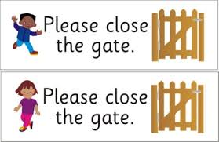We ask also that when entering/leaving school, that the school gate is shut behind you and ask that **parents and children should not use the school car park/gate to enter the playground**.

**Playground Safety**

If your child has an accident in the playground, he/she will be treated by a first aider. Your child will be given a head injury slip, which will inform you of the nature of the accident and the treatment given. We will attempt to notify you by telephone of any serious injuries.

During lunch/break times children will be expected to play outside unless the weather is excessively icy, wet or windy. Children should be sent to school with appropriate outerwear to suit the time of year.

In accordance with Aberdeen Council’s Health & Safety Policy, children will not be allowed to make ice slides in the playground nor throw snowballs.

**Lining Up**

Infants line up in the area outside the historical girls’ pupil entrance (adjacent to Hanover Street). P4-7 line up in the football pitch area round the back of the school. At bell times, they will be met by their teacher. At the end of morning and afternoon classes, the children leave by the same entrance. We ask that parents stand back, away from the lines, to allow the teachers to easily see and access their classes.

At the end of the day, we ask that parents wait in the playground for the children to be dismissed by their teacher. If you need to speak to your child’s teacher at the end of the day, please wait until all children have been picked up. If you have a lot to discuss it would be appropriate to make an appointment first, as the Class Teacher may have after school commitments such as staff meetings, professional development training, etc.

**Anti-Bullying Policy**

Relationships in school should be characterised by respect, kindness and consideration. In our school, all adults, children and young people have a responsibility to help each other to develop positive attitudes and behaviour, and to avoid using their power to bully or to prevent others from learning. Everyone has the right to feel valued and respected, and to develop self-esteem, a sense of belonging, and a feeling of being safe.

Our responsibilities are set out in the United Nations Convention on the Rights of the Child:

***"Children have the right to be protected from being hurt and mistreated, physically or mentally. Governments should ensure that children are properly cared for and protect them from violence, abuse and neglect by their parents, or anyone else who looks after them." (Article 19)***

UNICEF are promoting Rights Respecting Schools which not only teach about children's and human rights but also model rights and respect in all their relationships: adults-pupils; pupils-adults; pupils-pupils.

School staff play an important part in helping young people to develop mature and happy relationships, which is an important part of the curriculum and central to their present and future success in life. Schools are places where young people can learn and practice the skills of positive interpersonal relationships.

Positive relationships among all members of the school community produce an environment that is conducive to all aspects of learning and without which learning can be greatly impeded.

We do not tolerate bullying behaviour of any kind.

The school will treat all reports of bullying seriously and will investigate these appropriately.

We are currently finalising our school’s Anti-Bullying Policy. In the meantime, we follow Aberdeen City Council’s Education and Children’s Services Anti-Bullying Policy, which can be found here:

<https://www.aberdeencity.gov.uk/services/education-and-childcare/school-life/anti-bullying-policy>

It is also available on our school website.

# Anti-Weapon/Knife Policy - Life Not Knife Campaign

In Aberdeen City Council schools the safety and wellbeing of all pupils, staff and visitors is of paramount importance and we ensure that Hanover Street follows the correct procedures in order to minimise risk. A zero tolerance approach to the possession of a weapon or knife in school has been implemented in order to ensure, as far as possible, that pupils, staff and visitors are kept safe from harm.

Within our curriculum we will educate all pupils on the risks of weapon/knife crime and the serious consequences of carrying an offensive weapon. Aberdeen City Council’s Anti-Weapon/Knife School Rules are available on:

<https://www.abernet.org/2017/02/22/anti-weapon-crime-school-pack/>

**Accidents/First Aid**

If your child has an accident in the playground or becomes ill during the day, he/she will be treated by a first aider. For “head bumps”, your child will be given a head injury slip, which will inform you of the nature of the accident and the treatment given. We will attempt to notify you by telephone of any serious injuries. (Please ensure that you keep the school updated of any change in your emergency contact details/new mobile phone number.)

**Physical Education (P.E.)/Gym Kit**

For health and safety reasons, we ask that children have a suitable gym kit.

This should consist of:

* a drawstring gym bag
* slip on gym shoes
* shorts
* hair bobbles/bands for tying up hair
* micropore tape for covering earrings – otherwise to be removed; (see jewellery code of practice) and
* spare pants/trousers/tights/skirt in case of any “accidents”.

**\*AGAIN, PLEASE LABEL ALL CLOTHING (GYM KIT AND SCHOOL UNIFORM) CLEARLY.**

**Long hair tied back**

(Dlugie wlosy zwiazane z tylu)

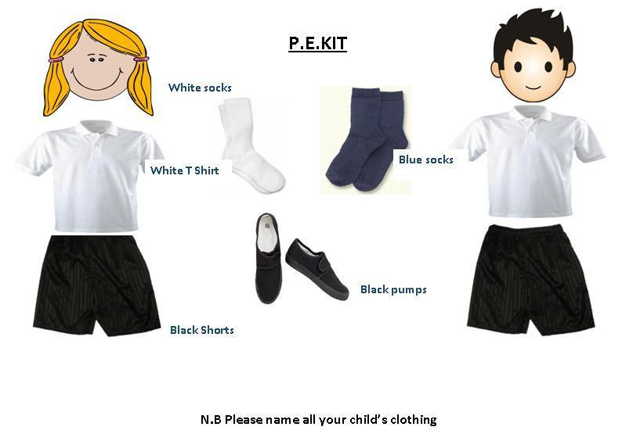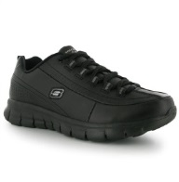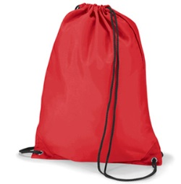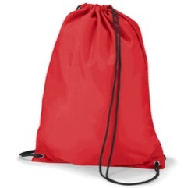

**T-shirt**

**Shorts**

(bluzka z krotkim rekawem

Kratkie spodenki

**Jewellery Removed**

Bez bizuteru

**Gym Shoes**

Buty do sportu

**Code of Practice for Jewellery in Physical Education**

**Gym Bag**

torba sportowa

**Introduction**

Aberdeen City Council (ACC) recognises its duty to ensure, so far as is reasonably practicable, the health, safety and welfare of employees and those affected by its activities. The wearing of personal effects, such as jewellery and watches, can present risks of injury to the person and / or others involved in an activity. Exposure to the risk of injury from such items can principally occur in Physical Education.

**Code of Practice Aim**

To ensure that employees and others, such as school pupils, taking part in Physical Education lessons are aware

* of the hazards of wearing jewellery & watches
* that control measures are in place to avoid the risk of injury
* that to enable individuals to understand that, as well as the right to protection, they also have to exercise responsibility

**Code of Practice Scope**

This policy applies to all Council schools where persons who are wearing jewellery and watches can potentially expose themselves and others to the risk of injury while taking part in Physical Education.

**PROCEDURE**

The following advice has been checked by our legal team. It applies to ALL body jewellery and watches and is to be followed by all schools.

**1. There should be risk assessments in place for all PE activities e.g. rugby, football, hockey, etc.**

The risk assessments should be made specific to each activity. Wearing of jewellery should be identified as a hazard in each risk assessment with a subsequent control measure (exemption from activity, removal/cover-up of jewellery/watch, adjustment to activity, etc.). The risk assessments should be written.

**2. All schools should follow the advice of the Association for PE as follows:**

**The basic rule is that all jewellery should be removed as this then removes that particular hazard.**

Where an item of jewellery cannot be removed then it is the adult teaching the group’s responsibility to try to establish a safe situation to enable participation by considering how, or if, the context can be made safe by amending the task, conditioning the activity or creating some other management strategy to make participation safe. Where safe participation cannot be assured then the pupil cannot take part in that element of the lesson.

It is good practice to regularly ask if anyone is wearing body jewellery. If they disclose this then the process of removal or considering whether safe participation can be made possible should apply.

If there is no disclosure but some body piercing is seen during the session then from that point the process above needs to be applied – remove, make safe or take no further participation in aspects of the session that would put the wearer or others at risk.

Pupils should remove their own jewellery. This should be made clear to parents and carers. If the child is unable to do this themselves, they should not wear any. School policy should explain this to parents from the outset.

**3. The basics of the above to be displayed in PE changing rooms, gyms etc.**

**4. PE teachers should remind classes of this at the start of every lesson.**

If teachers/schools follow the advice above, and risk assess, there should be no comeback if a pupil hides jewellery then has some jewellery related injury.

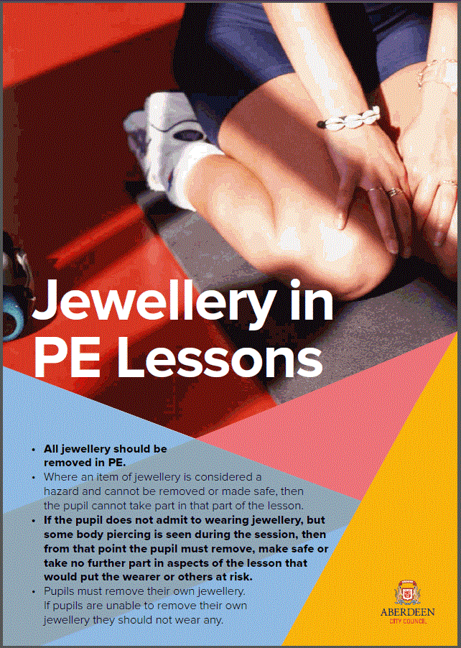

**T – TEAMWORK**

**Welcoming and Including Parents**

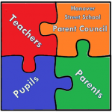Finally, this induction is not simply all about your children! As parents, you are a hugely valued part of the school community – you have been your child’s first teachers and provide the main role-model in their lives. It therefore makes sense that we work together as much as possible. Your support is greatly appreciated.

**Parent Council**

Hanover Street School has an active Parent Council, which relies on the support of every parent in the school. You are a member of the Parent Forum and will receive regular updates on its activities. Please try to help by becoming involved and supporting organised events.

The role of the Parent Council is to:

* support the school in its work with pupils;
* represent the views of all parents;
* encourage links between the school, parents, pupils, pre-school groups and the wider community; and
* report back to all the parents in the school (parent forum)

**Parent Helpers**

We hope that many of you will consider lending a hand as a parent helper in school, either on an ad hoc or regular basis. Aberdeen City Council requires all parent and adult helpers in school to complete a disclosure application before helping in school. If you’d like to help in any way, please see the class teacher.



**CURRENT STAFF & CLASS LIST FOR SESSION 2019-20**

**Senior Leadership Team:**

Head Teacher Mr Alan Markey

Depute Head Teacher Miss Gillian Forbes

**NURSERY TEAM:**

**Nursery Teacher:** Miss Rosie Smith (Tues - Fri)

**Senior Early Years Practitioner (S.E.Y.P):** Mrs Sarah Lemmon (Mon – Fri)

**Early Years Practitioners (E.Y.P):** Mrs Ludmila Barkovska (Mon – Fri)

Miss Kirsty Anderson (Mon – Fri)

Mrs Rhonda Gauld (Mon & Tues)

Mrs Laura Henderson (Mon & Tues)

Mrs Morag Scott (Wed – Fri)

Mrs Kelly Smith (Trainee: Mon – Wed)

**Class Teachers:**

P1N Mrs Natalie Stables

P1D Mrs Davina Smith

P2 Miss Catherine Sabbagh

P3 Mrs Alison Gray & Mrs Elizabeth Elrick (Tues)

P3/4 Miss Lillian Shivas (Tues-Fri) & Mrs Fiona Williamson (Mon)

P4 Miss Leanne Mainland

P5 Miss Jennifer Bloomfield

P6 Mr Jed Gilchrist

P7 Mr Graham Robertson & Miss Jennifer Wallace (Tues)

**Wider Staff Team: Additional Support Needs (ASN) & Non-Class Contact Time (NCCT)**

ASN/NCCT Miss Jennifer Wallace (Numeracy & P.E.)

NCCT (P.E.) Mrs Fiona Williamson

NCCT (Music) Mrs Leanh La Gray

Pupil Equity Funding Staff Mrs Margaret Duff (ASN - Nurture)

Mrs Gillian Fiddes (ASN - Literacy)

**Visiting Specialists Pupil Support/Classroom Assistants**

Miss Laura McGowan (E.A.L.) Mrs Susan Shepherd

Mrs Carol Walker (E.A.L.) Mrs Kirsteen Coutts

Mrs Zuzanna Ship (E.A.L.) Miss Sandra Anderson

Mr Alex Warham (Singing/Musicianship) Mrs Shelly Aros

Miss Patricia Milne (Piano) Mrs Gail Ingram

Mr Alan Haggart (Brass) Miss Michelle McLeman

Mrs Elizabeth Renwick (Vocal Instructor) Mrs Debra Bowie

**Support Staff**

School Administrator Mrs Claire Mutch

School Support Assistant Mr Leigh Wilson/Mrs Pauline Glendinning

Janitor Mrs Diane Strachan

Cleaning Team Olya, Esthera, Kevin, Darren

**Catering Team**

Mrs Wendy Mackie/Mrs Karen Lawson Mrs Deborah Reid

Mrs Justyna Grzonka Mrs Anna Platek

**Wider School Community:**

Educational Psychologist: Mrs Fiona Nicol

School Chaplain: Lt. Helen Froud (Salvation Army, Aberdeen Citadel)

School Nurse: tbc

Active Schools Coordinator: Joanna Bell

Parent Council Chairperson: tbc

**Enrolment Pack Contents**

**2019-20**

**Information for reading:**

1. Aberdeen City Council’s Guide to Integrated Children and Family Services, 2019-20 available on: <https://hanover.aberdeen.sch.uk/wp-content/uploads/2019/02/Guide-to-Integrated-Children-and-Family-Services-2019-20.pdf>
2. Weapon Awareness Parent Leaflet

**Consents to be signed/information to be completed on enrolment:**

1. Pupil Enrolment Form
2. Parental Consent Booklet (internet, etc.)
3. Medical Information Form
4. V4 Consent Form
5. Aberdeen City Council’s Anti-Weapon/Knife School Rules
6. Information Gathering Sheet for Class Teacher