

Welcome to
Hanover Street School

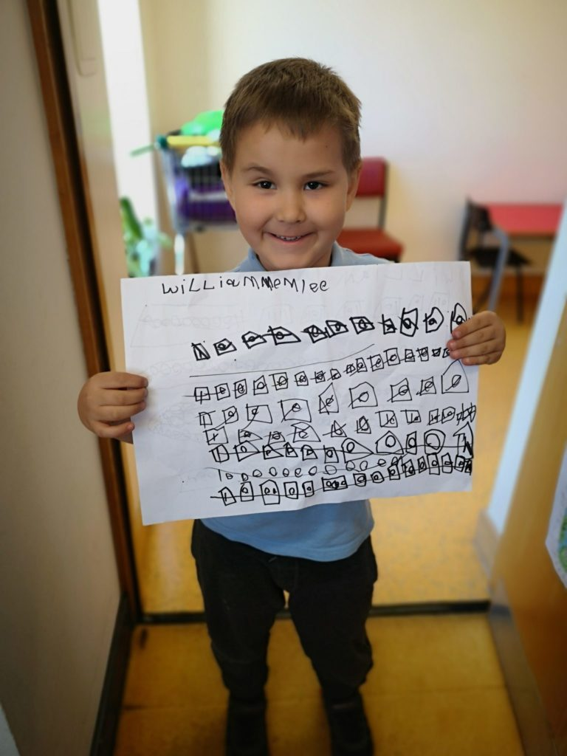
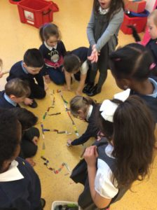


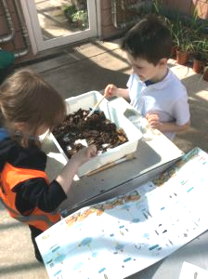


Beginning Primary 1!
Induction Information for Parents
2019/20

CONTENTS

- Welcome letter from the Senior Leadership Team, Mr Markey (HT) & Miss Forbes (DHT)

Priority Information
- School Vision, Values and Aims
- Starting School – Important People, Dates and Times
- Arrival/Pick-Up Information
- School Times and Term/Holiday Dates
- Uniform & Gym Kit
- Snacks and Lunches

Additional Information, Linked to our School Vision/Acronym, “HANOVER ST”
H – Happy & Healthy
- Outdoor Play…………………………………………………………………………………………………………….14
- Sickness, Head Lice, Medication.………………………………………………………………………………..…...14
- School Health Service……………………………………………………………………………………………….…14
- Childsmile! (Toothbrushing and fluoride varnishing)…………………………………..……………………….…...15
- Clubs & Activities…………………………………………………………………………………………………….…15

A – Achieving
- Early Learners’ Aims ……………………………………………………………………………………………..……16
- Our Curriculum, Curriculum Levels & Wider meaning of “Curriculum” ……………………………………….16/17
- Parental Partnership in Supporting Learning and Achievement …………………………………………….……18
- Homework & Summer Holiday Challenge …………………………………………………………………..………18

N – Nurturing
- The principles of nurture and what this means for you and your child…………………………………………….19
- Wrap Around Care………………………………………………………………………………………………………19

O – Our Communities
- Learning for Sustainability & Global Citizenship………………………………………………………………….….20
- Community Partnerships……………………………………………………………………………………….……….21

V – Valued
- Communication & School Office…………………………………………………………………………………….…22
- Home/School Communication Methods………………………………………………………………………….…...22
- School Closure Website Address………………………………………………………………………………….…. 23

E – Engaged & Equitable
- Additional Support Needs (A.S.N.)………… …………………………………….……….………………………….24
- English as an Additional Language (E.A.L.)…………………………………….……………………………………24

R – Respected & Responsible
- Positive Relationships & Behaviour Policy……………………………………………………………………………25
- Expectations of Staff, Parents and Pupils…………………………………………………………………………….26
- Anti-Bullying Policy……………………………………………………………………………………………….……...27

S – Safe
- School Security and Access for Parents………………………………………………………………..……….……28
- Child Protection……………………………………………………………………………………………………….…29
- Code of Practice for Jewellery in Physical Education…………………………………………………………….…30
- Aberdeen City Council Anti-Weapon/Knife Crime Policy………………………..………………………………….31
- Road & Playground Safety…………………………………………………………………….…………………….…31
- Lining Up…………………………………………………………………………………………………..…………..…31
- Accidents/First Aid……………………………………………………………………………..……………………..…31

T – Teamwork
- Welcoming and Including Parents……………………………………………………………………..…………...…32
- Parent Council, Parent Helpers……………………………………………………………………………..……...…32
- Parent Skills & Interests……………………………………………………………………………………….……….32

 | Hanover Street School  Beach Boulevard  Aberdeen  AB24 5HN  Direct Dial: 01224 569880  hanover@aberdeencity.gov.uk |   Integrated Children & Family Services  Operations  Marischal College  Broad Street  Aberdeen, AB10 1AB  Switchboard 03000 200 292  www.aberdeencity.gov.uk
Dear Parents/Carers

Welcome to our induction process. As parents, you have been and will always remain the first and main on-going educators of your children. Therefore, parental partnership now, and in the years ahead is the key to success for your child.

‘Parents, carers and families are by far the most important influences in a child’s life. Parents who take on a supportive role in their child’s learning make a difference in improving achievement and behaviour.’
(Guidance on the Scottish Schools
(Parental Involvement) Act 2006)

We know that, for the most, moving from nursery to primary school is an exciting and proud time. We also acknowledge that for some, it can be emotional and overwhelming, and a few parents and children may have some anxieties about this change. Throughout induction, we hope to give to the necessary information to make you and your child’s start in Primary 1 as smooth and as easy as possible. So, please be reassured that our transition and induction processes are robust, and your children are supported very well to settle happily into Primary 1.

In addition to the transition events and other presentation information, we hope that this booklet will be a useful tool for you to refer to, leading up to your child starting with us for Primary 1. If you feel you require any further information at any point, please contact Miss Forbes at the school on the above phone numbers and email address or ask a member of our nursery or office teams.

Finally, thank you very much for your continued support in your child starting school.

Yours sincerely




The Senior Leadership Team (SLT)
Mr Alan Markey Miss Gillian Forbes
Head Teacher Depute Head Teacher
SCHOOL VISION, VALUES & AIMS

Vision Statement
Hanover Street School’s vision is to create a welcoming, friendly, happy and safe environment to enable our children to achieve to their full potential and become successful learners, confident individuals and responsible, effective contributors to society.

School Aims

Our School Aims are:
- to provide a welcoming, caring and friendly environment where children feel happy, safe and secure.
- to provide challenging and appropriate learning experiences to promote successful learners within a full and balanced curriculum;
- to promote responsibility, fairness, honesty and respect for others to enable children to become responsible citizens;
- to develop communication, co-operation, perseverance and resilience to create effective contributors to society;
- to encourage and develop good relationships between children, parents, staff and the wider school community.

School Charter and Acronym
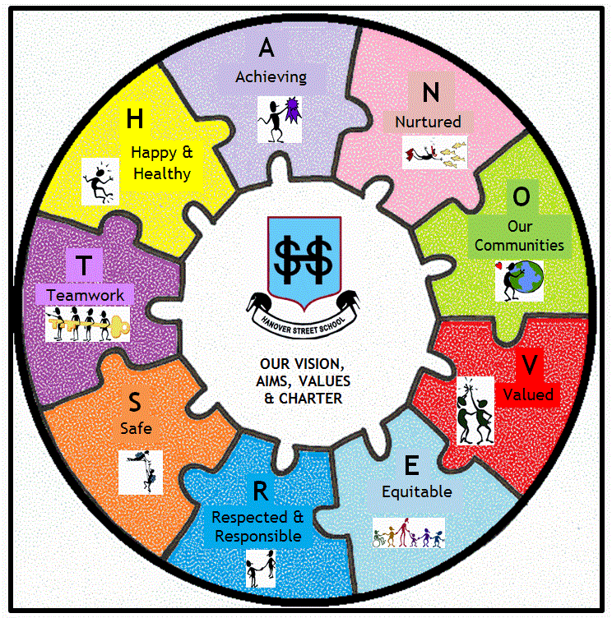
To make the above vision and aims more meaningful and memorable to the whole school community, we display and simplify these aims in the charter below, which uses the acronym “HANOVER ST.”
H – Happy & Healthy
A – Achieving
N – Nurturing
O – Our Communities (Being part of & involved with them)
V – Valued
E – Engaged & Equitable
R – Respected & Responsible

S – Safe
T – Teamwork

*To detail this vision, most of this booklet is organised under these headings
STARTING SCHOOL:
(IMPORTANT PEOPLE, DATES & TIMES)

Who will you meet, speak to or work with your child?

Staff
Head Teacher – Mr Alan Markey
Depute Head Teacher – Miss Gillian Forbes
School Administrator – Mrs Claire Mutch
School Support Assistants – Mr Leigh Wilson & Mrs Pauline Glendinning

Primary 1 Teachers
P1D: Mrs Davina Smith
P1N: Mrs Natalie Stables

Pupil Support Assistants (PSAs):
Mrs Anderson, Mrs Aros, Mrs Bannerman, Mrs Coutts, Mrs Ingram,
Miss McLeman, Mrs Shepherd, and other relief PSAs

Primary 1 Classes
We have two Primary 1 classes starting in August this year. A separate note with your child’s class and starting date is enclosed in your information pack.

*Please note, due to fluctuating numbers, classes may be subject to change, as well as staffing arrangements. You will be kept informed of any changes.

Across both classes, the children will start in 5 groups:

Group 1: Wednesday 21 August 2019
Group 2: Friday 23 August 2019
Group 3: Tuesday 27 August 2019
Group 4: Thursday 29 August 2019
Group 5: Tuesday 3 September 2019

In line with Local Authority policy, P1 children attend school in the morning only for the first three weeks of the session (9.00 – 12noon).

Full day sessions will commence on Monday 9th September.


SCHOOL HOURS

9.00 – 10.30am: 1st Morning session
10.30 – 10.45am: Break Time
10.45 – 12.30pm: 2nd Morning session
12.30 – 1.30pm: Lunch Time
1.30 – 3.15pm: Afternoon session

*On your child’s first day please meet myself in the playground at 9.20am.
You are welcome to come with your child to the classroom for a short while
and photographs are permitted.

ORGANISATION OF THE SCHOOL DAY/YEAR

Nursery
Morning class: 8.30am – 11.40am
Afternoon class: 12.20pm – 3.30pm

There is a staggered pick up and drop off time of 20 minutes for each nursery class.

Morning class drop off is between 8.30am – 8.50am and pick up is between 11.20am – 11.40am.

Afternoon class drop off is between 12.20pm – 2.40pm and pick up is between 3.10pm – 3.30pm. It is important that children do not arrive before or after these times.

Primary

Primary 1 | Primary 2 & 3 | Primaries 4 - 7
9.00 – 10.30am  Morning Break 10.30 – 10.45am  Lunch – 12.15pm  Afternoon – 1.30 – 3.15pm | 9.00 – 10.30am  Morning Break 10.30 – 10.45am  Lunch – 12.30pm  Afternoon – 1.30 - 3.15pm | 9.00 – 10.30am  Morning Break 10.30 – 10.45am  Lunch – 12.00noon  Afternoon – 1.00 –3.15pm

ARRIVAL/PICK-UP AT SCHOOL & PLAYGROUND INFORMATION

Children should not arrive at school more than 15 minutes before the start of the school day.


For pupils to reach their full potential, it is important that they arrive in time to come into school with their class ready to start the school day. It is also very important that children are collected on time. Young children can become confused and upset if they are left at school once all their classmates have left.

If you are going to be late for any reason, please contact the school office as soon as possible. If your child is to be collected by anyone other than their parent/carer you must let the school know too.

At the end of the school day, P1 – P3 pupils should be collected outside the early stages pupils’ entrance. If you are unable to collect your child, please ensure your child knows who he/she is going home with.

For health & safety reasons, dogs are not permitted in the school grounds.
SCHOOL TERM & HOLIDAY DATES

FOR SESSION 2019-20 (updated due to VE Day holiday)

Further information for sessions after 2019-20 can be found on

Aberdeen City Council Website: http://www.aberdeencity.gov.uk/

In Service Days (these are included into each term below)

Monday 19 August 2019 &Tuesday 20 August 2019
Thursday 21 November 2019 & Friday 22 November 2019
Tuesday 18 February 2020 & Wednesday 19 February 2020
Thursday 7 May 2020

Term 1 (8 weeks)
20 August 2019 to 11 October 2019

In-service days- Monday 19 August 2019 & Tuesday 20 August 2019
Term starts – Wednesday 21 August 2019
September holiday - Friday 20 September to Monday 23 September 2019
Term ends - Friday 11 October 2019
October holiday - Monday 14 October to Friday 25 October 2019

Term 2 (8 weeks)
28 October 2019 to 20 December 2019

Term starts - Monday 28 October 2019
In-service days – Thursday 21 November 2019 & Friday 22 November 2019
Term ends - Friday 20 December 2019
Christmas holiday - Monday 23 December 2019 to Friday 3 January 2020

Term 3 (13 weeks)
6 January 2020 to 3 April 2020

Term starts - Monday 6 January 2020
Mid-term holiday - Monday 17 February 2020
In-service day - Tuesday 18 February 2020
In-service day - Wednesday 19 February 2020
Term ends - Friday 3 April 2020
Spring holiday - Monday 6 April to Monday 20 April 2020

Term 4 (11 weeks)
21 April 2020 to 3 July 2020
Term starts - Tuesday 21 April 2020
In-service day - Thursday 7 May 2020
May Day/75th Anniversary VE Day holiday - Friday 8 May 2020
Term ends - Friday 3 July 2020

SCHOOL UNIFORM

*please label all clothing (uniform, shoes, jackets, etc) clearly

School Uniform
We strongly encourage the wearing of school uniform – it promotes a sense of identity and belonging to the school, the children look smart and it is relatively inexpensive.

If buying from other shops/supermarkets, the primary school colours are: navy, grey & pale blue.
There is an expectation that pupils wear these colours from Primary 1 to 7.

The basic clothing should consist of:
- Girls - polo shirt, blouse, skirt, pinafore, trousers - grey/navy/black - jumper, cardigan - grey/navy
- Boys - polo shirt, shirt, trousers, shorts - grey/navy/black - jumper - grey/navy


School fleeces, sweatshirts and polo shorts, with the school logo are suitable for boys and girls and can be ordered online at https://myclothing.com/


To look after our school uniform, an overall (old shirt)
is recommended for art.


School Clothing Grants
Aberdeen City Council, and the school, can in some circumstances provide a grant towards the costs of school clothing and footwear if you receive certain benefits.

The current grant is £100 for both primary school and secondary school pupils. More information can be found here: https://www.aberdeencity.gov.uk/services/education-and-childcare/school-life/apply-school-clothing-grant

Name Labels
It is important that all belongings are labelled.
Lost property accumulates very quickly and is emptied termly.
Please label all shoes, jackets and uniforms to avoid loss of items.


If you’d like to use name labels, the school has an account with the following company:
https://www.mynametags.com/
School ID = #24111

Pupil Belongings - Valuables/Jewellery
Valuable possessions (including toys) should not be brought to school unless parents are prepared to accept the risk of damage or loss as the school is not insured for these purposes. Pupils are discouraged from wearing jewellery for health and safety reasons. Stud earrings are permitted but any other form of jewellery is not advisable. It is stressed that these measures are taken to ensure the safety of the children in our care.

GYM KIT

*please label all gym kit clearly also

Physical Education (P.E.)/Gym Kit

For health and safety reasons, we ask that children have a suitable gym kit.
This should consist of:
- a drawstring gym bag
- slip on gym shoes
- shorts
- hair bobbles/bands for tying up hair
- micropore tape for covering earrings – otherwise to be removed; (see jewellery code of practice) and
- spare pants/trousers/tights/skirt in case of any “accidents”
- no jewellery (see code of practice in “Safe” section)

P.E. Kit – What Should I Wear?
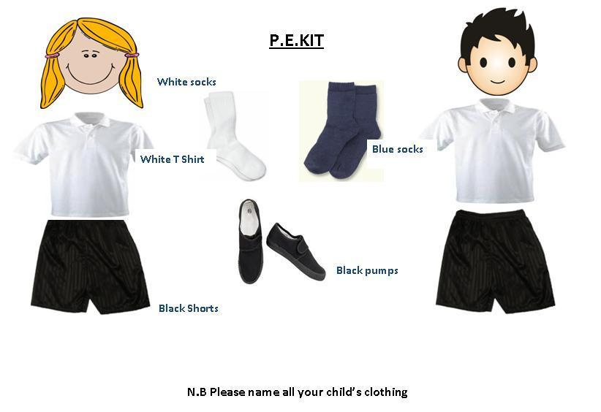


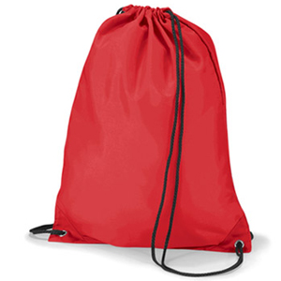
(co powinienem nosc?)

Long hair tied back
(Dlugie wlosy zwiazane z tylu)

Jewellery Removed
Bez bizuteru

T-shirt
Shorts
(bluzka z krotkim rekawem
Kratkie spodenki

Gym Shoes
Buty do sportu

Gym Bag
torba sportowa

SNACKS & LUNCHES

Health Promoting School

As a health promoting school we reinforce a positive message, encouraging healthy habits to children through the activities, experiences, snacks and drinks provided. In doing so, we hope to support you, the parent, in developing good lifestyles choices and eating habits for your child.

Snacks/“Playpieces”

Children can bring a snack to school for their “play piece”. A piece of fruit is what we encourage. As we are a health promoting school, crisps, sweets, biscuits, etc. are discouraged. Also, it is only a short time between break and lunchtime; if the children are eating only fruit they are more likely to enjoy a hearty lunch. For drinks, just like in nursery, milk and water are available each day. If you do wish to provide some juice however, we do discourage fizzy juice and energy drinks.

Water bottles can also be brought in by the children, but we do ask that it is only water that is kept in them.

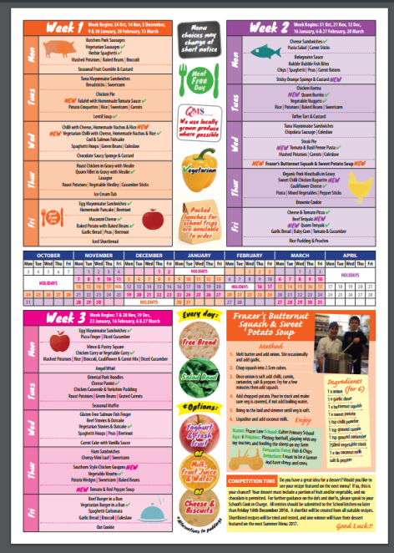
School Meals
Aberdeen City Council use a 3 or 4 weekly cycle menu. More information can be viewed on http://www.aberdeencity.gov.uk/schoolmeals/

In Scotland, school meals are provided free for every child in Primary 1-3 and are offered once the children begin all day attendance. School meals are cooked within our own kitchens. The children are offered a choice of 3 main courses and a dessert each day. A non-meat dish suitable for vegetarians is always one of the main courses on offer. Menus are always available to download from the school website. We send them through a link via text message, also.

Taster Sessions for Parents
Parents are given the chance to come for lunch with their child for a taster session.
This will take place the week before children begin all day attendance. Letters will be issued once your child has started school.

Packed Lunches
If you prefer, you can provide a packed lunch for your child. Please make sure that they can open packages and boxes with as little help as possible. Where children bring a packed lunch to school, parents are responsible for ensuring that lunch box contents are stored at the correct temperature, by including an ice pack where necessary. We ask that waste food and packaging are taken home with the children each day.

Supervision at Lunchtime

Children are encouraged to eat all their lunch, but not forced. The Senior Leadership Team, Pupil Support Assistants and older pupils assist in the dining room at lunch time. Good behaviour, table manners, and cleanliness is encouraged and reinforced. The school aims to encourage young people to enjoy food which is both attractive to them and nutritionally sound whether this is a school meal, a packed lunch or a snack. We would appreciate your support in achieving this aim.

*Please let us know if your child has any allergies or religious values for avoiding certain foods – for these reasons, a special diet can be requested.

Additional Information,
Linked to our School Vision/Acronym,
“HANOVER ST”
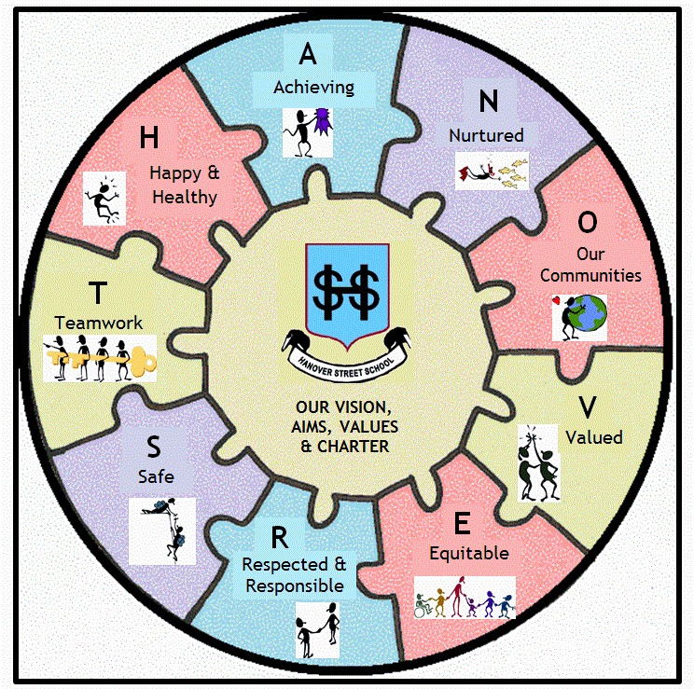
(For even more information, our full school handbook is available
on the school website)
H – HAPPY & HEALTHY
Outdoor Play

Unless the weather is excessively icy, wet or windy, children will be expected to play outside during playtime and lunchtimes. Children should be sent to school with appropriate outerwear to suit the weather and/or time of year.
*Please note, we do encourage playing in the garden, and other every day play activities such playing in the sand pit or using the mud kitchen. Please bear this is mind.

Sickness

Please do not be persuaded by an unwell child that – “they want to come to school.” Bringing a sick child to school puts all the other children and staff at risk. Children should not attend school for 48 hours after the last bout of any vomiting or diarrhoea.

Head Lice
We encourage the regular checking of heads for live head lice and eggs (nits). We offer termly reminders via newsletters/text messages. If you receive a reminder this does not mean there is an “outbreak” in school. Please, if you discover live head lice, do inform the school so that we can monitor the spread of any infection, and whilst maintaining confidentiality, can make other parents aware. Our “Management of Head Lice Prevention & Infection Policy” is available on our school website.


Medication
If your child needs medication at school, whether this is regular or infrequent, we are not able to administer it until the relevant permission forms and instructions are completed. These can be collected at the school office.

School Health Service
Early in the first term parents receive an envelope about “Health Services for School Age Children”. This will contain:
- Programme for Health – an information leaflet for parents.
- Parent Questionnaire – about your child’s health.
- Consent Form – for school doctor/nurse screening checks.
- Details about the school nurse.
- A return envelope.
We will ask you to complete all relevant forms and return them to school in a sealed return envelope. These will be collected by the school nurse.

Tooth Brushing & Fluoride Varnishing– Childsmile!
Childsmile aims to improve the oral health of children in Scotland and reduce health inequalities.


At Hanover Street, our tooth brushing programme begins in the nursery and continues through to the end of Primary 2. All the children are given their own toothbrush and teachers dispense the toothpaste and supervise the brushing. Brushing takes place whenever it is suitable for the class but it is recommended half an hour before or after food.

A letter is given to parent/carers informing them of the school/nursery participating in the tooth brushing programme. *If you do not want your child to take part in this, please write to the school within 2 weeks of receiving the letter.

A consent pack will be sent from Childsmile regarding consenting for the fluoride varnish which happens twice a year.


Clubs & Activities
We work closely with “SportAberdeen” and the Active Schools Network who help to develop and support the delivery of quality sporting opportunities for our pupils.

Throughout the session, your pupil may have opportunities to take part in sports/physical activities either during lunchtime and/or after school. In recent years, these clubs have included athletics, basketball and multi-activity club. Please see the letter in your pack for Active Schools, club/activity and emailing list information.
Information is also always available on our school website:
https://hanover.aberdeen.sch.uk/extra-curricular-clubsactivities/active-schools-clubs-activities/

A – ACHIEVING

Early Learners’ Aims (reviewed annually)

At Hanover Street School, to get it right for every early learner, we aim to:
- use a child-centred approach which enables the children’s rights, voice and interests to be valued and realised;
- build strong, positive, nurturing relationships with children and families, staff, community and other partnership agencies;
- respect and respond to children’s individual needs and wellbeing, creating a safe and inclusive environment, where children feel secure and develop resilience;
- promote active learning and development through indoor and outdoor play, where children’s curiosity, independence, thinking and creativity is challenged and extended;
- provide our best service through using open, reflective practices which engage all members of the early learning community.

We aspire to be a
fun, happy, engaging and ambitious setting,
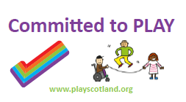
full of warmth, smiles and laughter.
😊

Our Curriculum

At the heart of the Scottish Curriculum for Excellence are the 4 capacities

- Successful Learners
- Confident Individuals

- Responsible Citizens
- Effective Contributors

The curriculum works towards achieving these through the 8 subject areas listed:

Language
- Listening
- Talking
- Reading
- Writing

Mathematics
- Number, Money & Measurement
- Shape, Position & Movement
- Information Handling

Health and Wellbeing
- P.E., physical activity and sport
- substance misuse
- food and health
- relationships

Expressive Arts
- Drama
- Music
- Art
- Dance

Religious and Moral Education
- Christianity
- World religions
- Development of beliefs and values

Sciences
- Planet earth
- Forces, electricity and waves
- Biological systems
- Materials

Social Studies
- People, past events and societies
- People, place and environment
- People, society, economy and business

Technologies
- Technological developments in society
- ICT to enhance learning
- Computing science
- Food and textiles
- Craft, design, engineering and graphics

Curriculum Levels

Progression is indicated through curriculum levels, as detailed below. Most children in P1 will be working within the Early level.

Level | Stage
Early | The final two years of early learning and childcare before a child goes to school and P1, or later for some.
First | To the end of P4, but earlier or later for some.
Second | To the end of P7, but earlier or later for some.
Third | S1 to S3, but earlier for some.


The Wider Meaning of “Curriculum”
The curriculum includes all the experiences which are planned for children and young people through their education, wherever they are being educated. These experiences are grouped into four categories.

- Curriculum areas and subjects
as detailed above
- Interdisciplinary learning (IDL)
how the curriculum should include space for learning beyond subject boundaries which will provide learners with the opportunity to develop insights and apply skills in a way and/or to a degree not offered through the study of a discrete curriculum area
- Ethos and life of the school
the starting point for learning is a positive ethos and climate of respect and trust based upon shared values with genuine engagement across the school community.
- Opportunities for personal achievement
children and young people need opportunities for achievements both in the classroom and beyond, giving them a sense of satisfaction and building motivation, resilience and confidence.

Added to this, because children learn through all their experiences - in the family and community, pre-school centre, nursery and school - the curriculum aims to recognise and complement the contributions that these experiences can make.

Following this guidance, we are currently developing our “Curriculum Rationale” for our own school and its own unique circumstances.

Parental Partnership in Supporting Learning and Achievement

Parents will be invited to curriculum workshops to find out about what children learn, how they learn, and ideas to support this at home, later in the session.

Parents’ evenings normally take place around October and April.
Formal written pupil reports are usually distributed prior to the April Parents’ evenings.

Homework
After settling into the Primary 1 routines, the pupils will begin to receive homework. We will be evaluating our homework policy this coming session. We fully encourage parents to support their children in completing their homework, signing reading diaries/jotters, as appropriate.


SUMMER HOLIDAY CHALLENGE!!!
Please look inside the paper bag to see what this is!

N – NURTURING

As a school, we are increasing our awareness of the ‘nurturing approach’ and embedding it further into our policies and practices.

There are 6 principles of nurture:

- Children's learning is understood developmentally
- The classroom offers a safe base
- The importance of nurture for the development of wellbeing
- Language is a vital means of communication
- All behaviour is communication
- The importance of transition in children's lives

Ref: Lucas,S., Insley,K. and Buckland,G. (2006)
Nurture Group Principles and Curriculum Guidelines Helping Children to Achieve,
The Nurture Group Network


What does this mean for you and your child?

We recognise that each child and family have different experiences and expectations of school. Starting “school” can be challenging, emotional and exciting – or a combination of all of these!

As a nurturing school, at Hanover Street, when your child and family needs care, comfort, guidance, and time, we try our hardest to give it to you. We talk, we listen, and we positively reinforce routines, expectations and boundaries, looking for solutions to any problems whilst respecting the uniqueness of each person/situation.

The children spend a lot of time here – for many of them, it is an extension of home. In comfort, we may give hugs (or in our Aberdeen dialect, a “bosie!”), put arms round shoulders, give pats on backs, sit the children on our knee, etc., as the needs of the young children dictate. Please, if you would like us not to hug your child in the event of them being upset, do let us know!

Wrap Around Care/Breakfast/After School Club/Childminders
We do not have a breakfast or after school club at Hanover Street School.
We do have some children from our school who attend the after-school club “Rising Light” http://www.risinglight.org.uk/

There are various child-minders in the area, who offer a care facility. https://www.childminding.org/
O –OUR COMMUNITIES
(BEING PART OF & INVOLVED WITH THEM)

At Hanover Street, we believe we are part of and contribute to our communities on all levels:
- Local
- National; and
- International & Global

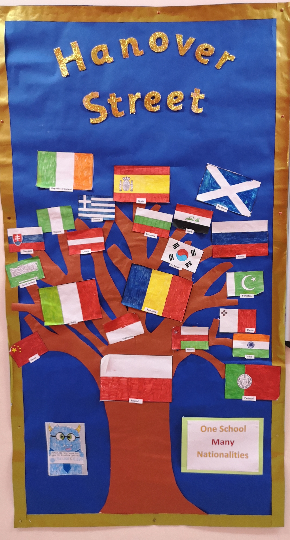
Our school is very fortunate to have a thriving, diverse community full of different cultures and experiences. Our school roll very much reflects the 21st century Scotland and brings huge benefits to learning about ourselves and the world we live in.

On our current school roll, over 50% of our pupils come from other cultures, speaking English as an additional language. We are therefore very well placed to promote the concepts of Learning for Sustainability and developing Global Citizenship, a key part of Scotland’s Curriculum for Excellence.

What Is Learning for Sustainability?
Learning for Sustainability is learning to live within the environmental limits of our planet and to build a just, equitable and peaceful society. It is essential for the well-being of all and is an international priority. (UNESCO, 2013)

It is concerned with every level and type of learning and the provision of quality education for all.

For a school it is 'a whole school approach that enables the school and its wider community to build the values, attitudes, knowledge, skills and confidence needed to develop practices and take decisions which are compatible with a sustainable and equitable world.' (Learning for Sustainability, The report of the One Planet Schools Group, 2012).

Hanover Street School is undertaking many aspects of this through the areas shown in the diagram below, and in other ways.



What is Global Citizenship?
A global citizen is someone who is aware of and understands the wider world - and their place in it. They take an active role in their community, and work with others to make our planet more equal, fair and sustainable.

At Hanover Street global citizenship is all about encouraging young people to develop the knowledge, skills and values they need to engage with the ever-changing world. And it's about the belief that we can all make a difference.

How do we promote this in school?

We have various working partnerships at Hanover Street School.

Local Community Partnerships
Aberdeen Salvation Army
Alzheimer’s Scotland
Local Sheltered Housing Associations
Various Local Branches of National Supermarket Chains
Working with schools in our ASG (Broomhill, Ferryhill, Kaimhill and Harlaw Academy)
NESCOL, Robert Gordon University and University of Aberdeen

National Community, International and Global Partnerships
We have various charitable links, which we focus on throughout the year:
NSPCC
Children in Need
Comic Relief
Rotary International
There is more! Have a look at the ‘community links’ part of the website for further information.
V – VALUED
(communication and participation)
Communication
We value information from you so that we can make your child feel and be included as much as possible. Please complete the P1 Information Gathering Sheet. This will highlight important information to your child’s teacher in an easy form.

School Office

Mostly, your first port of call to the school will be through the school office. The school office is manned from 8.30am –12.30pm & 1.30 – 3.15pm.
The school has an answering machine for leaving messages. Any visits to the school should be made through the main entrance and all visitors should report to the School Office. In line with Aberdeen City Council’s Health & Safety Policy, all visitors to school will be asked to sign in and wear a visitor’s pass badge.

Home/School Communication Methods


We consider our daily contact with you to be vitally important – time for us both to exchange information – for the benefit of your child. Please don’t rush away! It is helpful to share with staff any special events, or problems, happening out-with school – weddings, births, illnesses/bereavements, family splits etc. If we are informed, we can help your child should they become unsettled.

Please use the Reading Homework Diary that your child will receive to note down any queries/concerns if you cannot see the teacher at the end of the day.

At Hanover Street School we use various forms of communication:
- Telephone and face-to-face informal conversations (school number 01224 569880)
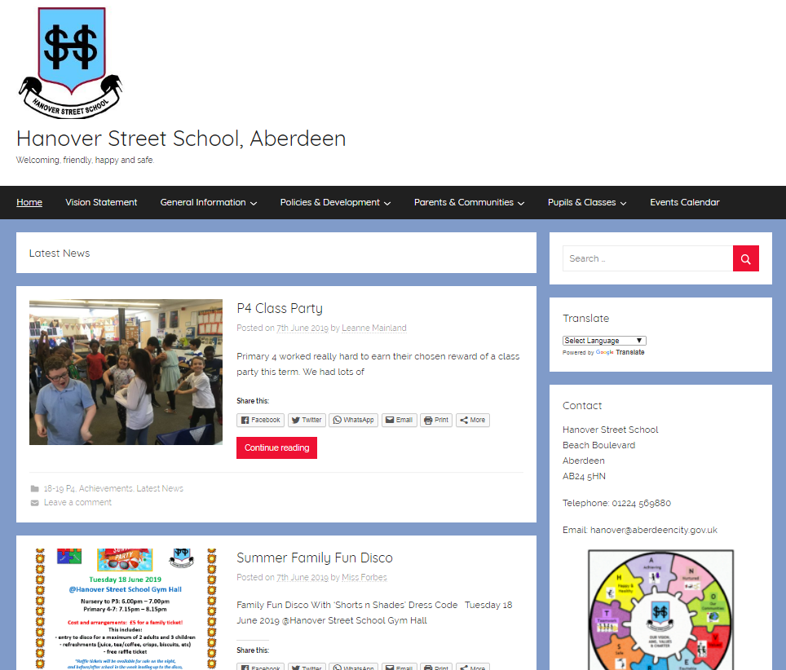
- Face-to-face parent meetings
- Annual written reports
- Newsletters
- School Information Line (See overleaf)
- GROUPCALL – a text messaging service for the school
- Class Dojo

We also have our school website: www.hanover.aberdeen.sch.uk
Here you can view the complete School Handbook, policies and other school, class and community information. You can also subscribe to receive email updates.



You can also follow us on Twitter: @HanoverStSch

*Please do take time to read and respond to these communications.
Your participation is greatly appreciated.

*Please also update any changes of telephone numbers, address and emergency contacts to the school office ASAP so that we can contact you with ease.

Schools Information Line

Aberdeen City schools provide a telephone information service for parents/guardians. This is the Schools Information Line.

The main features of this service are: Emergency Arrangements Message for Parents and Guardians (To be used to inform parents/guardian of emergency arrangements and important announcements, e.g. early closure arising from adverse weather conditions/failure of heating system.)

Voicemail for Recording Non-urgent Messages from Parents/Guardians

The system also has the potential to record brief messages of a routine nature from parents/guardians. We are not using this feature.

List of Messages containing School Information
This could hold routine information for parents/guardians, e.g. the times for a Parents Night, School Concert details, etc.

Parents/Guardian can access these features by dialling this National Rate number: 0870 054 1999

A Council message will be heard followed by a request for a six-digit PIN number specific to Hanover Street School – this is: 011390.

Once connected, a voice will speak out the name of the school and a series of prompts will guide you to the appropriate options.

The cost of the class is no more than 10p/call (landline calls)

School Closure Website Address

Parents can access the School Closure list by going to www.aberdeencity.gov.uk/school-closures

Parents are also advised to listen to school closure announcements on North Sound, Original 106 and/or BBC Scotland radio stations.

E – ENGAGED & EQUITABLE

Delivering Excellence and Equity is a key aim in Scottish Education. It is supported by international, national and local legislation.

Additional Support Needs (A.S.N.)
We at Hanover Street aim to identify and support any additional support needs children may have, be it social, emotional, behavioural or academic, short or long-term. If you feel your child is requiring further support in any of these areas, please speak to the class teacher in the first instance. As a school, we can access the support of other agencies and professionals to support these needs. These may support individual children, but also the wider family.



English as an Additional Language (E.A.L.)
We have teachers and Pupil Support Assistants who support children with E.A.L. The EAL Service supports learning and teaching of pupils with a home language other than English (bi/multilingual pupils) so that they reach their full potential.

The Head Teacher will contact the EAL Service for an initial assessment visit to decide on the level of support the child will need. This may be with talking and listening, reading, writing, phonics and spelling.

If any pupils are struggling in their understanding, we do our best to ask an older pupil to come and translate, if/when necessary.

R – RESPECTED & RESPONSIBLE

We always promote a respectful relationship and culture between:

- Pupils and pupils
- Pupils and all staff
- Pupils and parents
- Parents and all staff
- Pupils, parents and the wider community




Aberdeen City Council Schools are committed to becoming “Rights Respecting Schools (R.R.S)” where we make children, parents, staff and the wider community aware of the United Nations Convention for Rights of the Child (UNCRC).

We are a “Rights Committed (Bronze Level)” School. We aim to take R.R.S. further (to Silver or Gold level), embedding it into our curriculum and wider school activities. Look out for more information coming to you about this, soon!

Positive Relationships & Behaviour Policy
All young children respond favourably to praise and recognition, along with clear, and firm but fair boundaries. Our staff will deal with your child in a kind and caring manner, with clear expectations. Similarly, the children are encouraged to treat each other and adults with respect and to be kind and caring, respecting these expectations and boundaries.

We ask that parents co-operate with us in encouraging children, by offering praise when their child copes with a difficult situation, achieves a goal, masters a new skill or behaves well.

Promoting rights, respect, resilience and providing praise within nurturing boundaries are all key parts of our Positive Relationships & Behaviour Policy (available on our school website). In this policy, we state clear expectations for staff, parents and pupils. These are detailed overleaf.

Expectation of Staff
- A strong understanding of the concept of “universal support,” focusing on delivering learning to meet individual needs
- Promotion of positive, caring, inclusive, fair ethos, climate and relationships
- Devising and refreshing class charters, relating to school charter and needs of class/pupils
- Provide a safe and secure classroom environment
- Use of positive, rights respecting language and modelling behaviour and mutual respect for all of school community
- Responsive to children’s needs - personal learning/individualised education planning with regular analysis and evaluation of successes/areas for development, undertaking career-long professional learning as required
- Provide children with regular opportunities to discuss their learning, development, relationships and/or behaviour
- Provide additional or “targeted support,” tailoring it to pupils’ individual circumstances, removing barriers to learning as far as possible
- Allowing pupils appropriate choices and opportunities to achieve positive outcomes
- Communicate and record information clearly with relevant staff, parents, partners and agencies

Expectation of Parents/Carers
- Acknowledgement of parental role as prime/first educators
- To work together/in partnership with the school and other agencies
- Attendance and punctuality for pupils and parents (e.g. at start and end of day)
- For children to arrive, as far as possible, in a positive mindset, appropriate labelled clothing/belongings, ready for learning (adequate sleep, nutrition, etc.)
- Modelling respectful behaviours – especially in and around school
- Open communication – share important information with us
- Support with homework, other learning tasks and home/school communication systems
- Discuss relationships and behaviours at home, with a positive mindset
- Ask for support if/when required – we can access many agencies/provide some useful strategies to support at home
- Respect the confidentiality and needs of other children and families

Expectation of Pupils
- Show respectful behaviour to ALL members of staff and pupils
- Choose safe behaviours, make others and yourself feel safe
- Focus on learning – it is the right of all
- Ask for help when you need it
- Use your best efforts
- Accept mistakes and failure – this is an important part of learning
- Listen to each other
- Valuing others’ opinions/feelings
- Respectful of people’s space
- Respectful of resources and property

Anti-Bullying Policy

At Hanover Street School, we aim to provide an environment free from bullying behaviour, in turn supporting children to achieve their potential.

The organisation ‘respectme’ is Scotland’s anti-bullying service. They define bullying as:

‘Bullying is both behaviour and impact; the impact is on a person’s capacity to feel in control of themselves. This is what we term as their sense of ‘agency’. Bullying takes place in the context of relationships; it is behaviour that can make people feel hurt, threatened, frightened and left out. This behaviour happens face to face and online.”
(respectme, 2015).

Our anti-bullying policy is based on current legislation, national guidance and best practice. It is reviewed on an annual basis and is available on the school website.

Here is a section of the policy – a handy guide for parents/carers. Again, this is available on the school website.
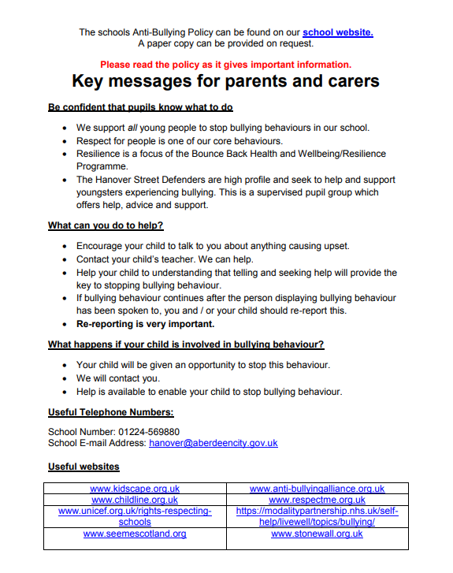

S – SAFE
School Security and Access for Parents
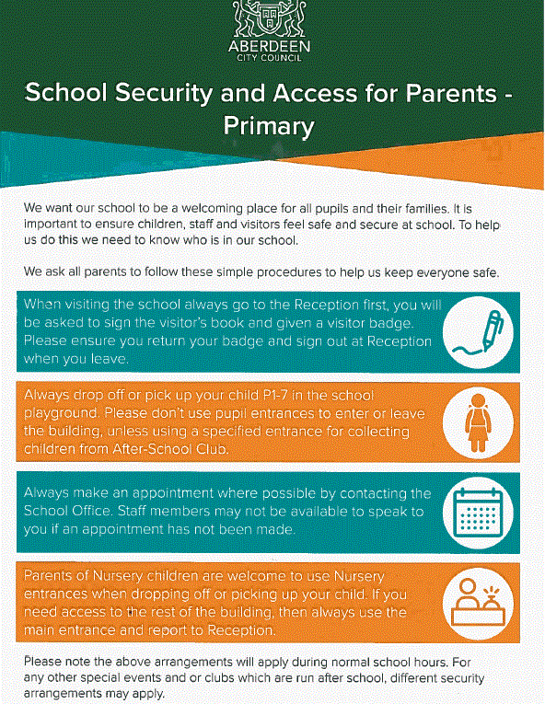

Child Protection
Schools are required by law to report any suspected harm done to a child by possible abuse. Every school has a named senior member of staff appointed responsible for Child Protection matters. GIRFEC legislation refers to this as the ‘Named Person.’

In our school that person is the Head Teacher, Mr Markey. Or, in his absence, it is Miss Forbes, Depute Head Teacher. Please see the notice below:


Code of Practice for Jewellery in Physical Education

Aberdeen City Council have a code of practice for the wearing of jewellery in Physical Education. The full version of this is available on our school website. For your information the summarised poster is below:

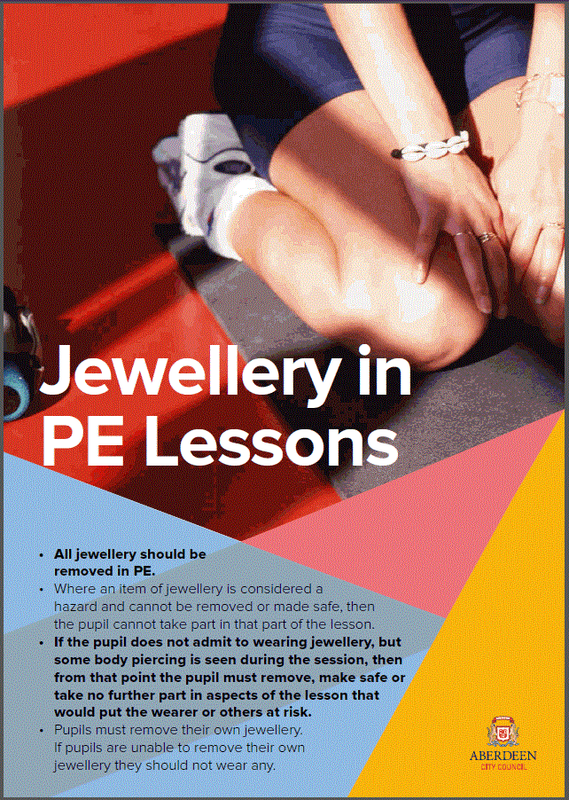


Aberdeen City Council Anti-Weapon/Knife Crime Policy
Aberdeen City Council launched an anti-weapon/knife crime strategy in March 2017. The policy is on the school website.
The anti-weapon/knife crime strategy aims to:
- highlight weapon/knife crime and the consequences of carrying a weapon
- raise awareness about the types of situations that can lead to violence
Hanover Street School follows local and national guidance to prevent and/or deal with any weapon/knife incidents.

Road & Playground Safety

When travelling to and from school you can encourage good road safety habits by using the marked crossings and by always holding your child’s hand when crossing roads.

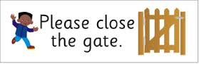
We ask also that when entering/leaving school, that the school gate is shut behind you and ask that parents and children should not use the school car park/gate to enter the playground.
Lining Up

In the morning and after lunch, the children line up outside the historical girls’ pupil entrance (adjacent to Hanover Street) where they will be met by their teacher. At the end of morning and afternoon classes, the children leave by the same entrance.

At the end of the day, we ask that parents wait in the playground for the children to be dismissed by their teacher. If you need to speak to your child’s teacher at the end of the day, please wait until all children have been picked up. If you have a lot to discuss it would be appropriate to make an appointment first, as the Class Teacher may have after school commitments such as staff meetings, professional development training, etc.

Accidents/First Aid
If your child has an accident in the playground or becomes ill during the day, he/she will be treated by a first aider. For “head bumps”, your child will be given a head injury slip, which will inform you of the nature of the accident and the treatment given. We will attempt to notify you by telephone of any serious injuries. (Please ensure that you keep the school updated of any change in your emergency contact details/new mobile phone number.)
T – TEAMWORK

Welcoming and Including Parents
Finally, this induction is not simply all about your children! As parents, you are a hugely valued part of the school community – you have been your child’s first teachers and provide the main role-model in their lives. It therefore makes sense that we work together as much as possible. Your support is greatly appreciated.
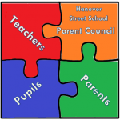
Parent Council
Hanover Street School has an active Parent Council, which relies on the support of every parent in the school. You are a member of the Parent Forum and will receive regular updates on its activities. Please try to help by becoming involved and supporting organised events.

The role of the Parent Council is to:
- support the school in its work with pupils;
- represent the views of all parents;
- encourage links between the school, parents, pupils, pre-school groups and the wider community; and
- report back to all the parents in the school (parent forum)


Parent/Adult Helpers
We hope that many of you will consider lending a hand as a parent helper in school, either on an ad hoc or regular basis. Aberdeen City Council requires all parent and adult helpers in school to complete a disclosure application before helping in school. If you’d like to help in any way, please see the school website for our policy, and then see a class teacher.


Parent Skills and Interests
If you have a certain skill, interest or passion, do let us know, so that we can benefit from your parental participation too! This participation may be in one-off visits (such as talking about a hobby/job), or something more regular, for example, as part of one of our pupil leadership groups: Pupil Council, Eco-Committee, Rights Respecting Steering Group, After-School/Lunchtime Clubs, Library Group, PEEP Group, etc.

