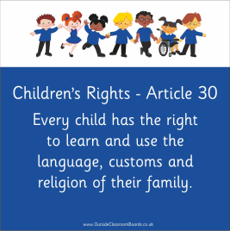
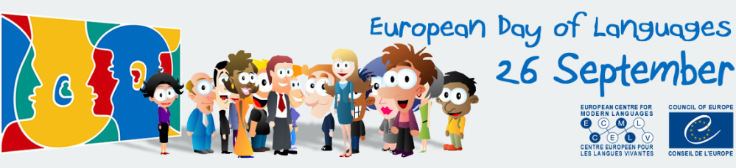

Classes will be participating in some activities to celebrate
“European Day of Languages”
Thursday 26 September 2019.
As part of this we would like to hold a “Eurovision (World Vision) Song Contest,” where children sing/perform a song in their native language. This may be a pop song, a traditional song, a folk song, or if this is too scary, even a poem or dance.

Children will perform in their classes on Thursday 26th and then a selection of acts will perform in front of the school at assembly time on Friday 27th.

Pupils of the same nationalities, but from different classes can join together.
(e.g. Polish friends singing together from P5 & 6, Scottish friends from P1 & 2).
Also, it is not restricted to just European languages.
World languages, such as Arabic, Urdu, etc., are of course invited to join in!
Flags can be brought in and native dress may also be worn!

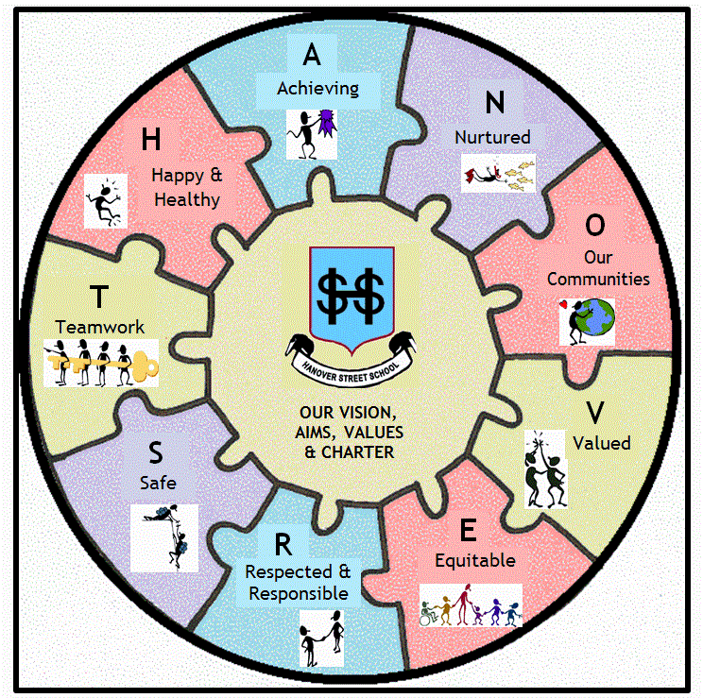
The idea is to celebrate the fantastic diversity & multi-culturalism we have here at Hanover Street School and to further connect “Our Communities,” as is in our School Vision, shown here.

Children are asked to source their own music.
But if the music is available on you tube,
then please note the link down on the slip below to help teachers find the correct, appropriate music:
Name(s) of Child(ren): Class(es):
Native Language: Native Country:
Song Title: Artist:
Web-link to song/video:

