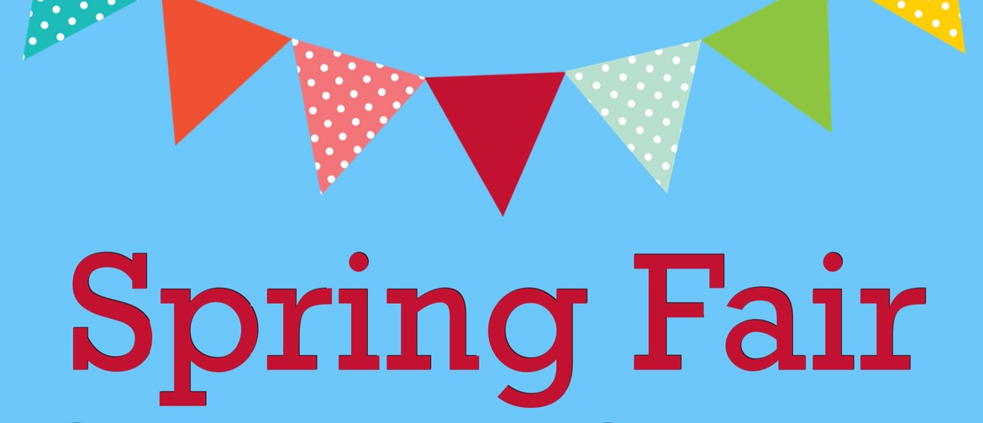
Hanover Street Primary May Fair
18th May 2024
11:00am – 1:00pm
Entry
Adults £2 – Children £1
Under 3’s free
(Tea & Coffee included –
Soft drinks can be purchased)
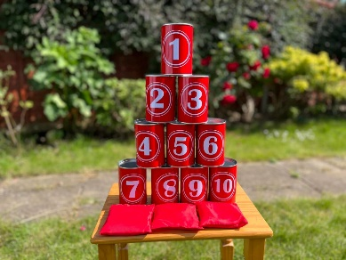
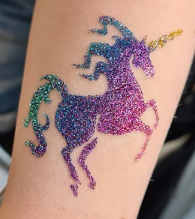
Paid Stalls – Glitter Tattoos, face painting, Tombola’s, Beat the Goalie, Outdoor Fair Games section including Hook a duck & Tin can Alley! And a BOUNCY CASTLE!!!!! Plus lots more….
CASH ONLY

Follow our Monopoly trail and bag yourself a wee prize at the end, Free Arts & Crafts Table and special guests including Love Rara, Sea Cadets & North East Rider Volunteers Scotland

We will also welcome some fabulous business stalls for you to browse and support – Elidhs Bookshop, Avon Beautiful with Emma, Cuddly Creations by Kayleigh, Homemade Jams & preserves, Just a wee Gift, Teigan’s Toys, Crafty Creations by Emma, Beautiful Unicorns Crystals, LR Luxurious Scents and Popcorn & Candyfloss from Candy Box and more!

